**EBook Web Application User Manual**

Table of Contents

What is EBook? 2

How many module does EBook have? 2

What are the names of modules in EBook? 2

How to login into EBook? 3

What major types of functionalities are there in EBook? 3

How to add the new Contact details and search it through EBook Web Application? 3

How to view the Companies details through EBook Web Application? 6

How to assign an EBook user to a specific Section, Team Lead and Security Profile and set the User active? 6

How to Insert, Edit or Delete User Access Rights 7

How to access change log? 9

How to view the recent deleted Job History? 10

How to view the information about Contract Number changes? 10

How to change the Password? 11

How to access Cost Control Section task? 12

How to access Payment Section task? 14

How to access Document Control Section task? 17

How to access Budget Section task? 18

How to access Planning and Scheduling task? 20

How to access Manager Request’s task? 23

How to access Business Support task? 27

How to access Documents? 29

How to access Search My Document? 30

How to access Receive Upload Documents? 30

How to access My Documents? 31

How to access Reports? 33

How to access Project Coordinators in EBook application? 34

How to navigate to the dashboard of EBook application? 36

# What is EBook?

An EBook is a web application, which use for creating, managing the documents as well as projects in Ashghal. It also helps in generating reports about the KPI’s (Key Performance Indicators) of the staff in the various sections of Ashghal. It captures the input of the users through various web forms of its different modules for achieving the business objective of Engineering Services Department of Ashghal.

# How many module does EBook have?

EBook has fifteen modules. These are a combination of functional and technical modules.

# What are the names of modules in EBook?

The following are the names of modules in EBook web application:-

|  |  |  |
| --- | --- | --- |
| **No.** | **Functional Module** | **Technical Module** |
| 1 | Payments Section | Admin |
| 2 | Planning and Cost Control | Document Management |
| 3 | Document Control | Job Orders |
| 4 | Tender Services |  |
| 5 | ESD Strategy |  |

1. Admin
2. Contracts Control
3. Documents
4. Document Controller
5. Job Order
6. Users Directory
7. ESD Strategy
8. General Services
9. GIS (Geographic Information System for EIS)
10. Manager Tasks
11. Payments
12. Planning
13. Reports
14. Tender Services Section
15. Guest

# How to login into EBook?

After entering the <http://mv2ebdbookp01/ebook/> url address in the address bar of the web browser, the following web page will open:-

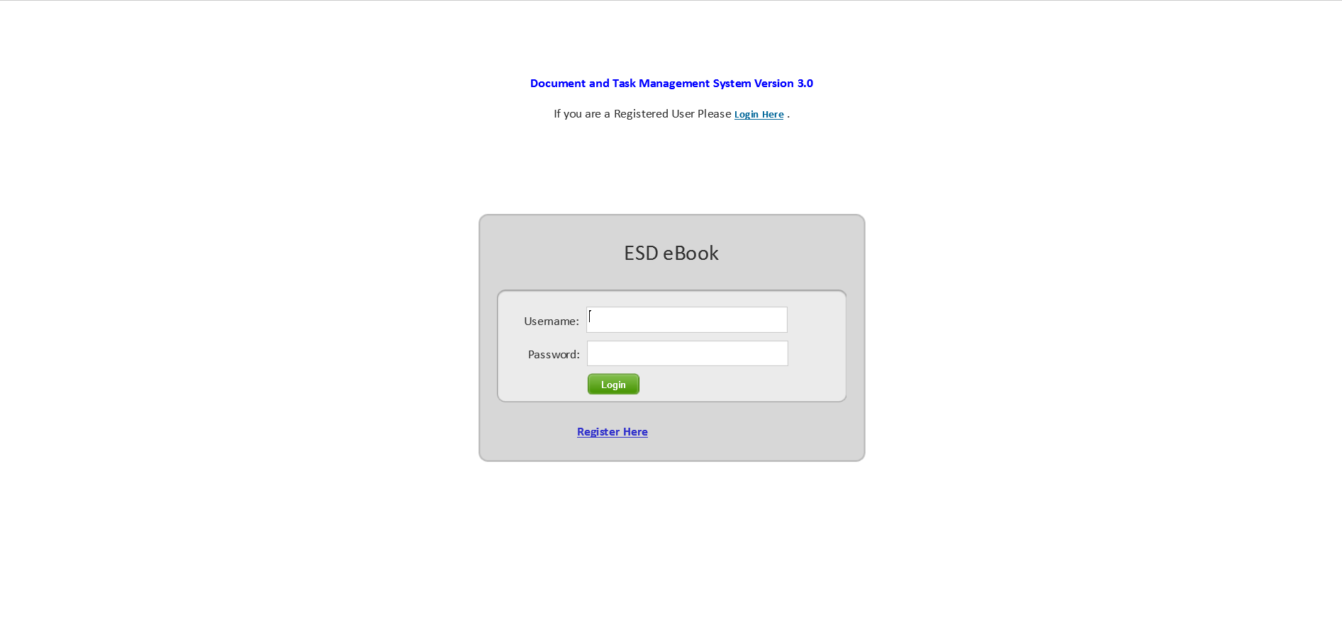

# What major types of functionalities are there in EBook?

Create New Job, Search Jobs, Create New Documents, Search Documents, and View Reports.

# How to add the new Contact details and search it through EBook Web Application?

1. After login into EBook Web application, select Directory menu item from the menu bar on the top of EBook website. Click on “Contacts” menu item. The purpose of Contact module is to create and store contact details of the EBook users and the persons whose names are required for uploading the documents that are not the user of EBook application.

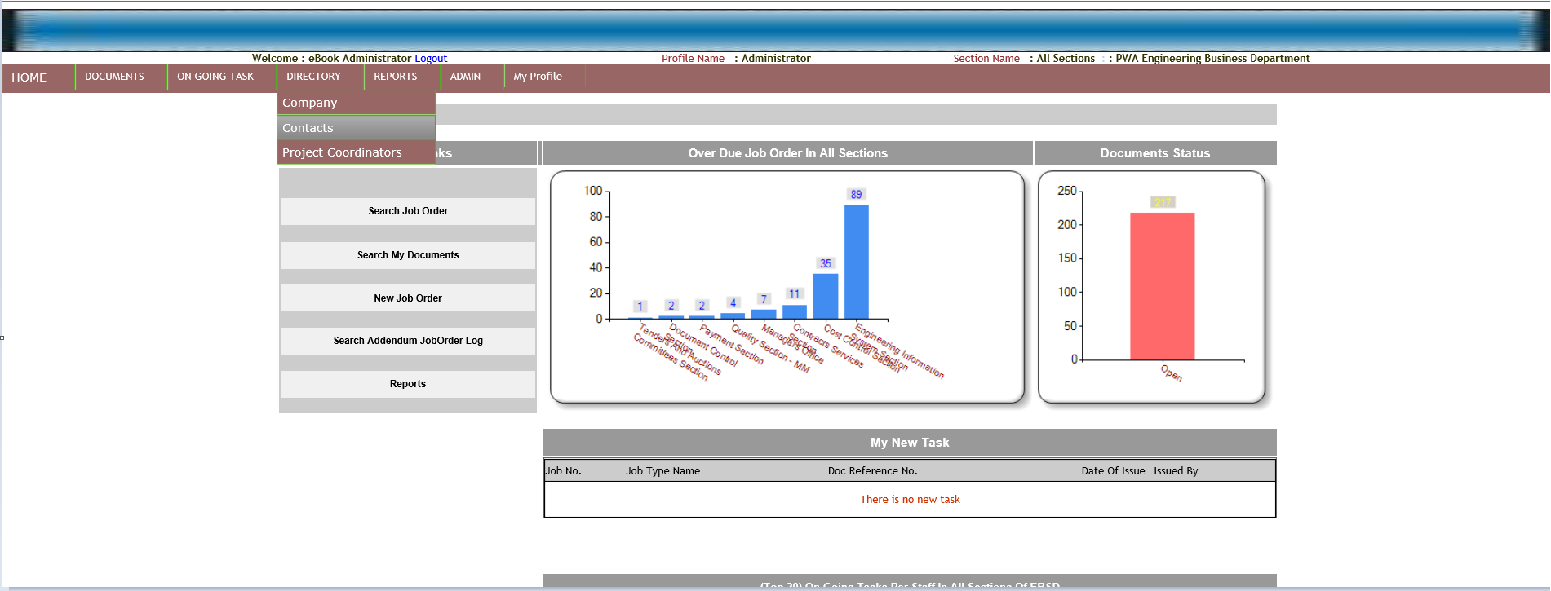

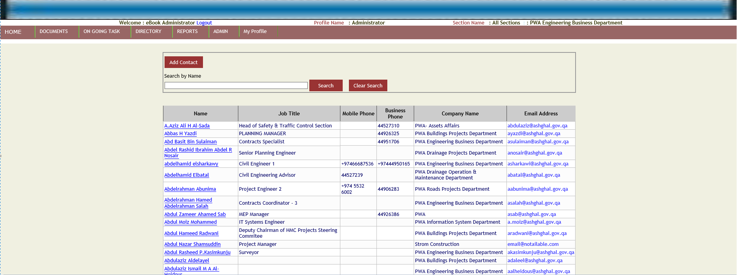

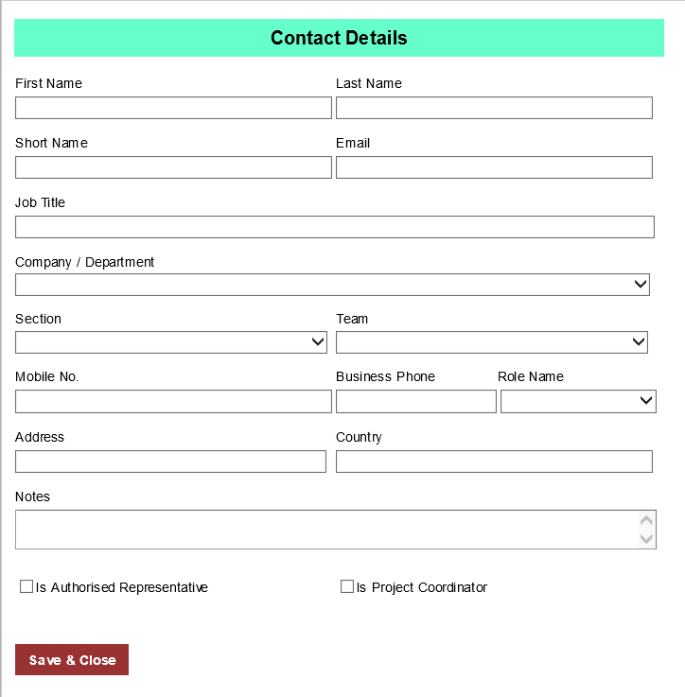

1. Click on Add “Contact” button for adding the contact details. After entering the contact name inside Search by Name textbox, click on “Search” button for searching for the particular contact name.

# How to view the Companies details through EBook Web Application?

1. After login into EBook Web application, select Directory menu item from the menu bar on the top of EBook website. Click on “Company” menu item.

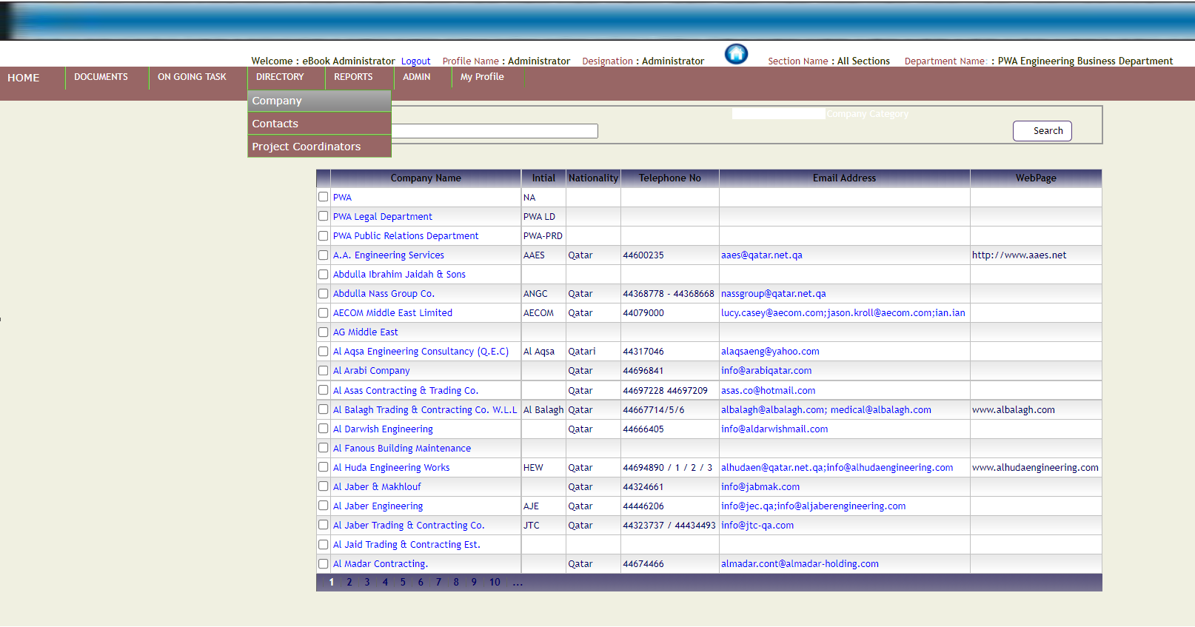

1. Enter Company name in the “Company Name” textbox and click on “Search” button. The application will display company information in the tabular format.

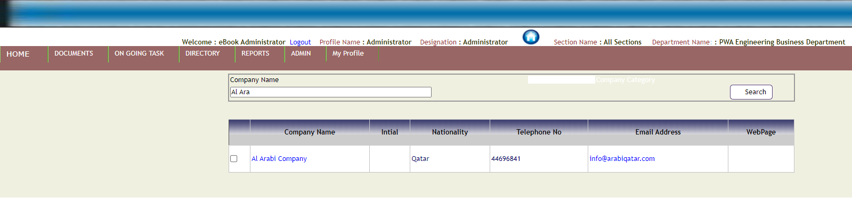

# How to assign an EBook user to a specific Section, Team Lead and Security Profile and set the User active?

1. By selecting User Info menu option under Admin menu bar.

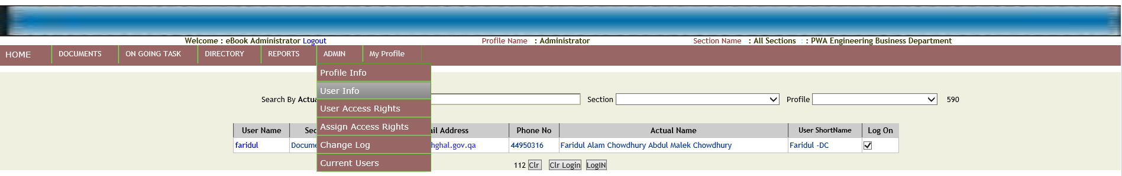

1. Search by Actual Name. Type the username that exists in the EBook application.

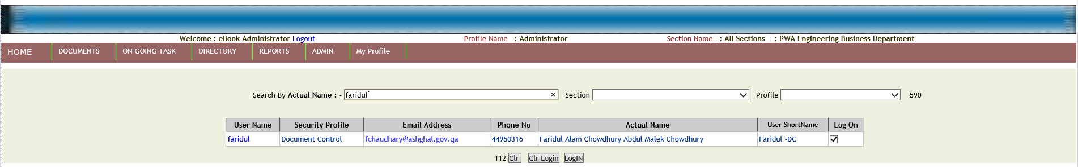

1. Click on the hyperlink inside “User Name” column. A “User Information” popup window will open. It will display user info.

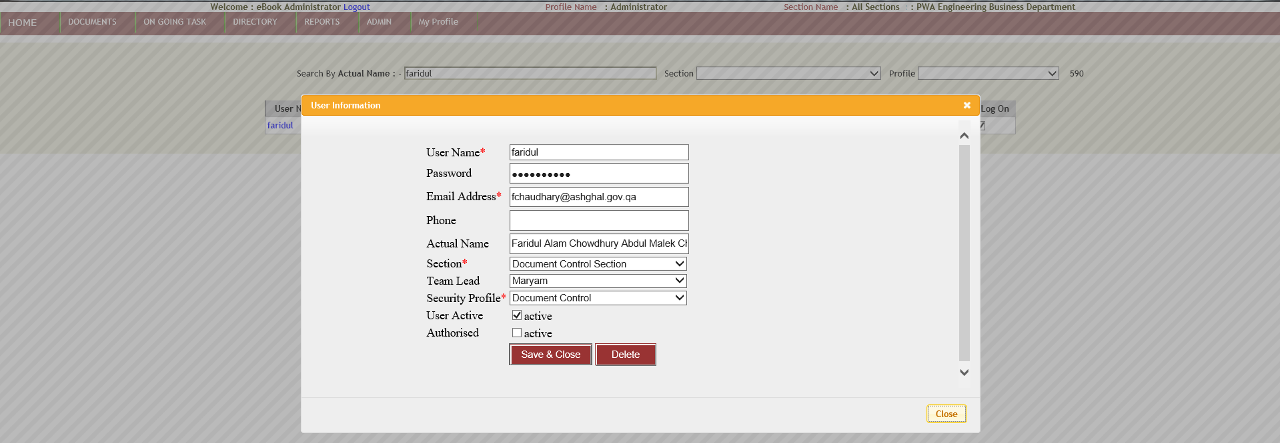

1. Application user can change Section, Team Lead and Security Profile of the selected User Name. By checking or unchecking the checkbox user can change the active status of the user. Similarly, user can change the Authorized status of the user. After change in the values inputs specified above, user clicks on “Save & Close” button.
2. User clicks on “Delete” button for deleting the User Name.

# How to Insert, Edit or Delete User Access Rights

1. By selecting User Access Rights menu option under Admin menu bar.

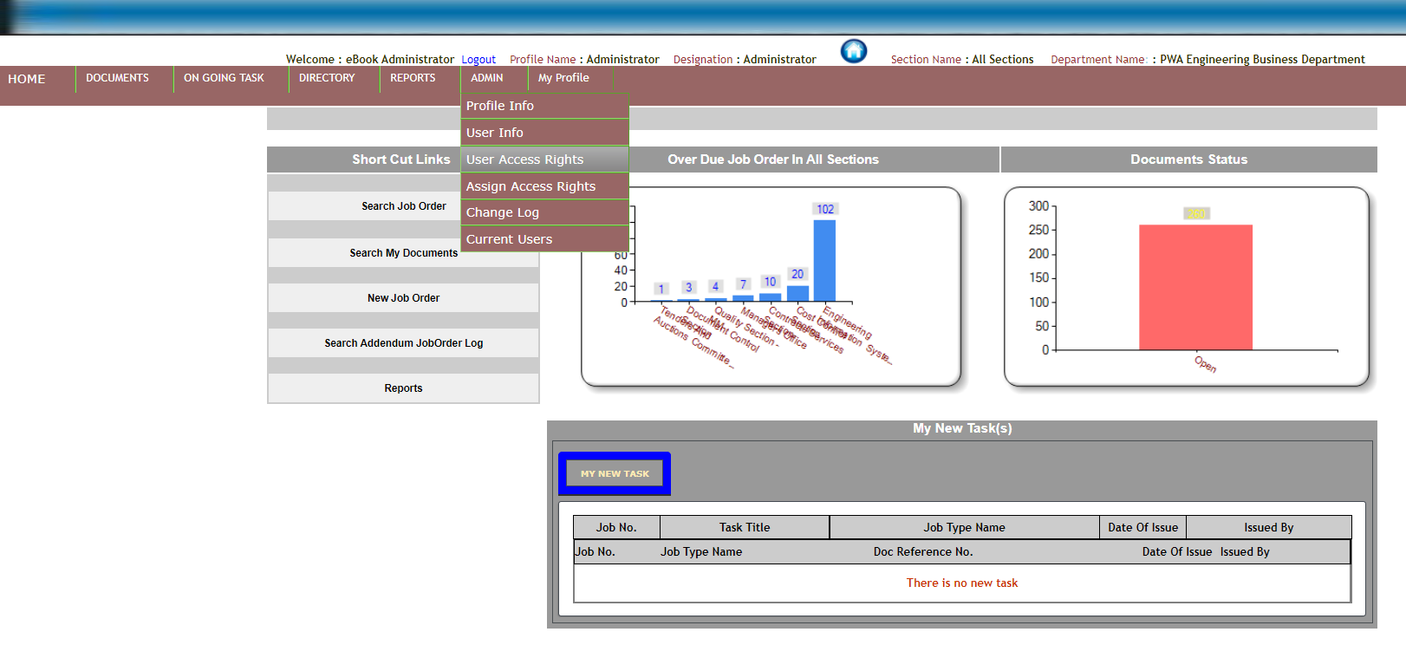

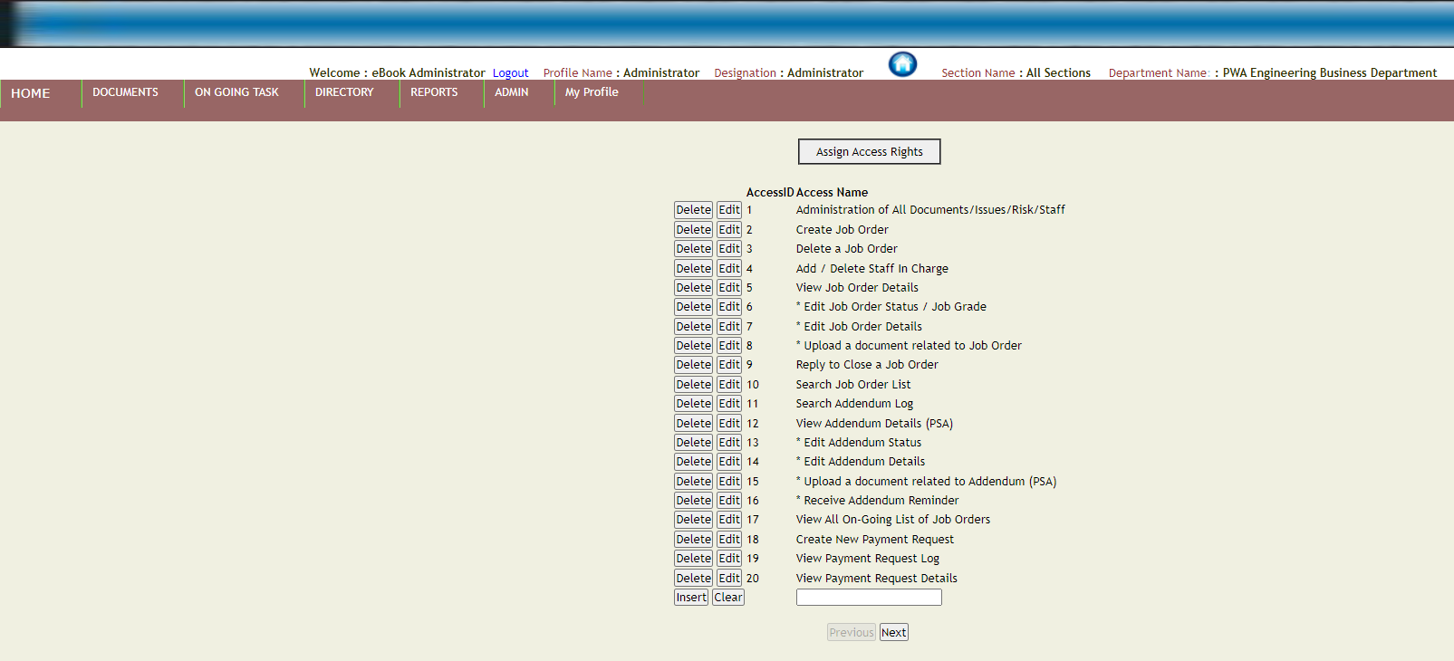

1. To insert new access name, enter access name inside the textbox and click on “Insert” button.
2. To edit access name, click on the edit button on the left side of access name.

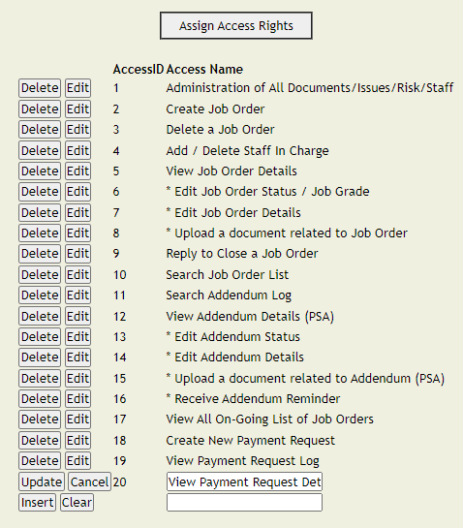

1. The access name will convert into a textbox and edit button will change to Update and Cancel button. After modifying the access name click on the update button to save the modified changes. Click on Cancel button to discard the changes.
2. To delete the access name, click on the delete button on the left side of access name for deleting the access name.

# How to access change log?

Navigate from Admin menu to “Change Log” menu option. “CriticalChangeLog” web page will display the information about those jobs that are link with some other jobs.

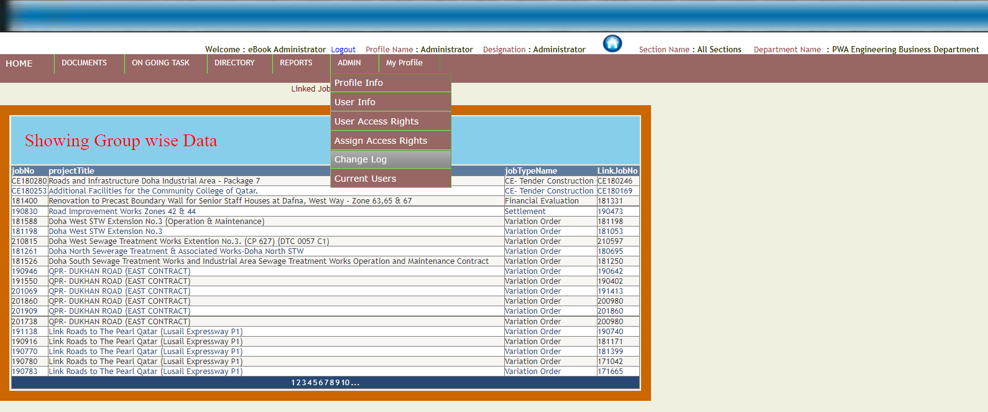

# ­How to view the recent deleted Job History?

Navigate from Admin menu to “Change Log” menu option. “CriticalChangeLog” web page will display the recently deleted Job History information in the form of a table.

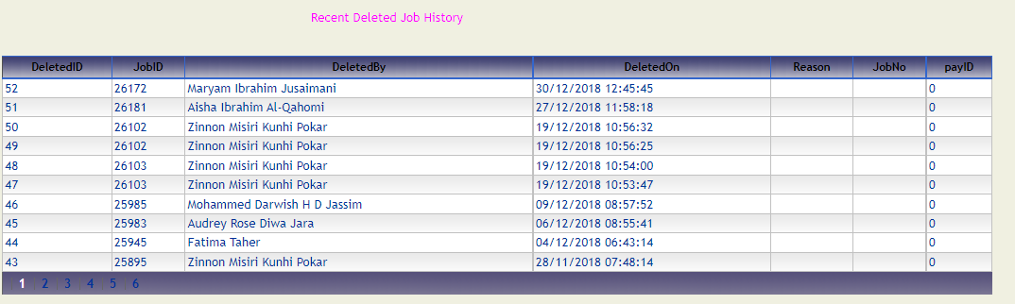

# How to view the information about Contract Number changes?

Navigate from Admin menu to “Change Log” menu option. “CriticalChangeLog” web page will display the information that relates to the contract number changes in the form of a table.

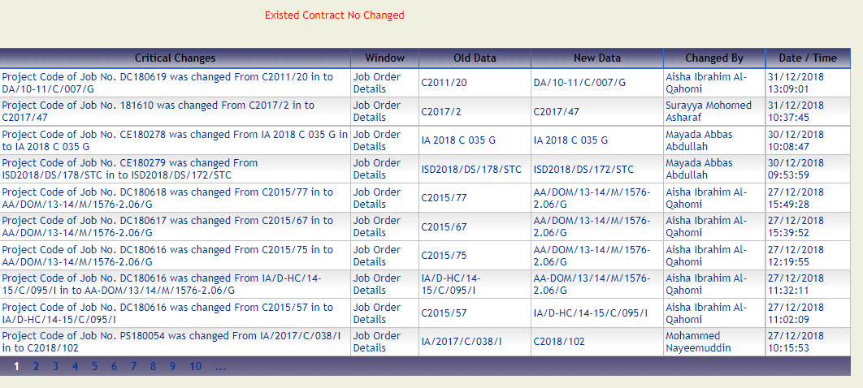

# How to change the Password?

1. Hover the mouse cursor on My Profile main menu on the menu bar. Click on “Update Password” submenu.

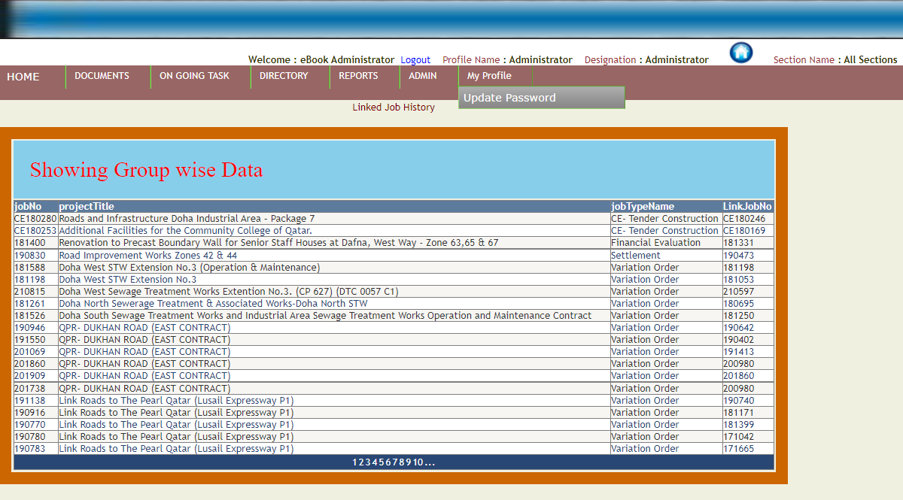

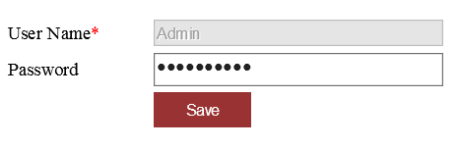

1. Enter the password in the password textbox to change the password of the specific username.

# How to access Cost Control Section task?

1. Hover the mouse cursor on “On Going Task” main menu on the menu bar. Click on “Cost Control Section” submenu.

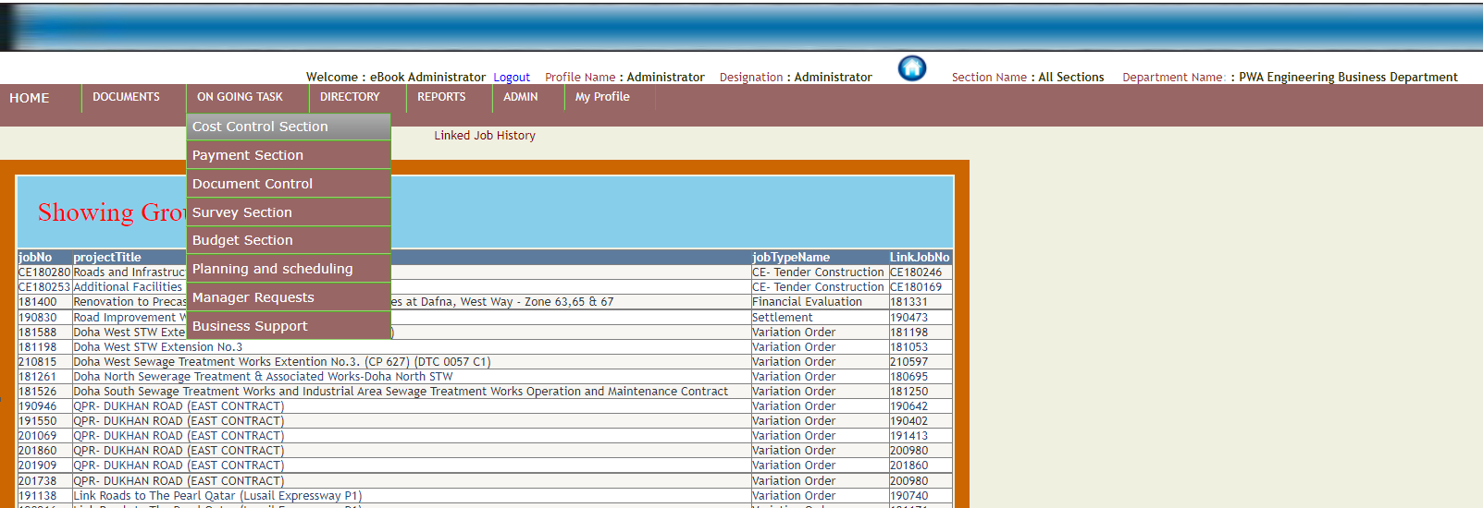

1. There are three types of contracts under cost control section. These are Committed, Non- Committed and PSA contracts. By default Committed contracts tab will display the jobs to the application user.

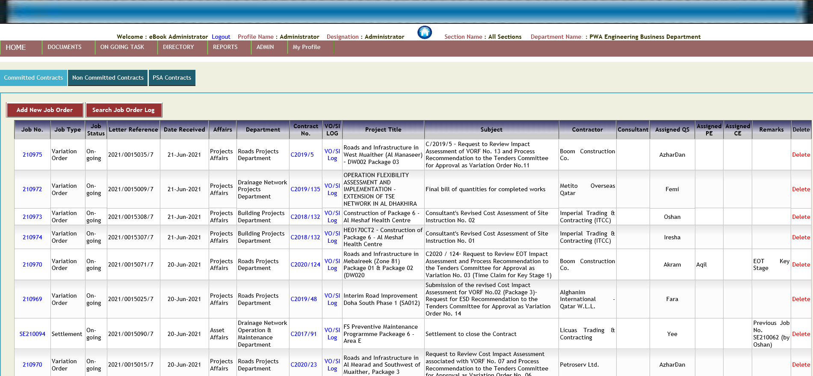

1. User clicks on the Job Number the following page will display :-

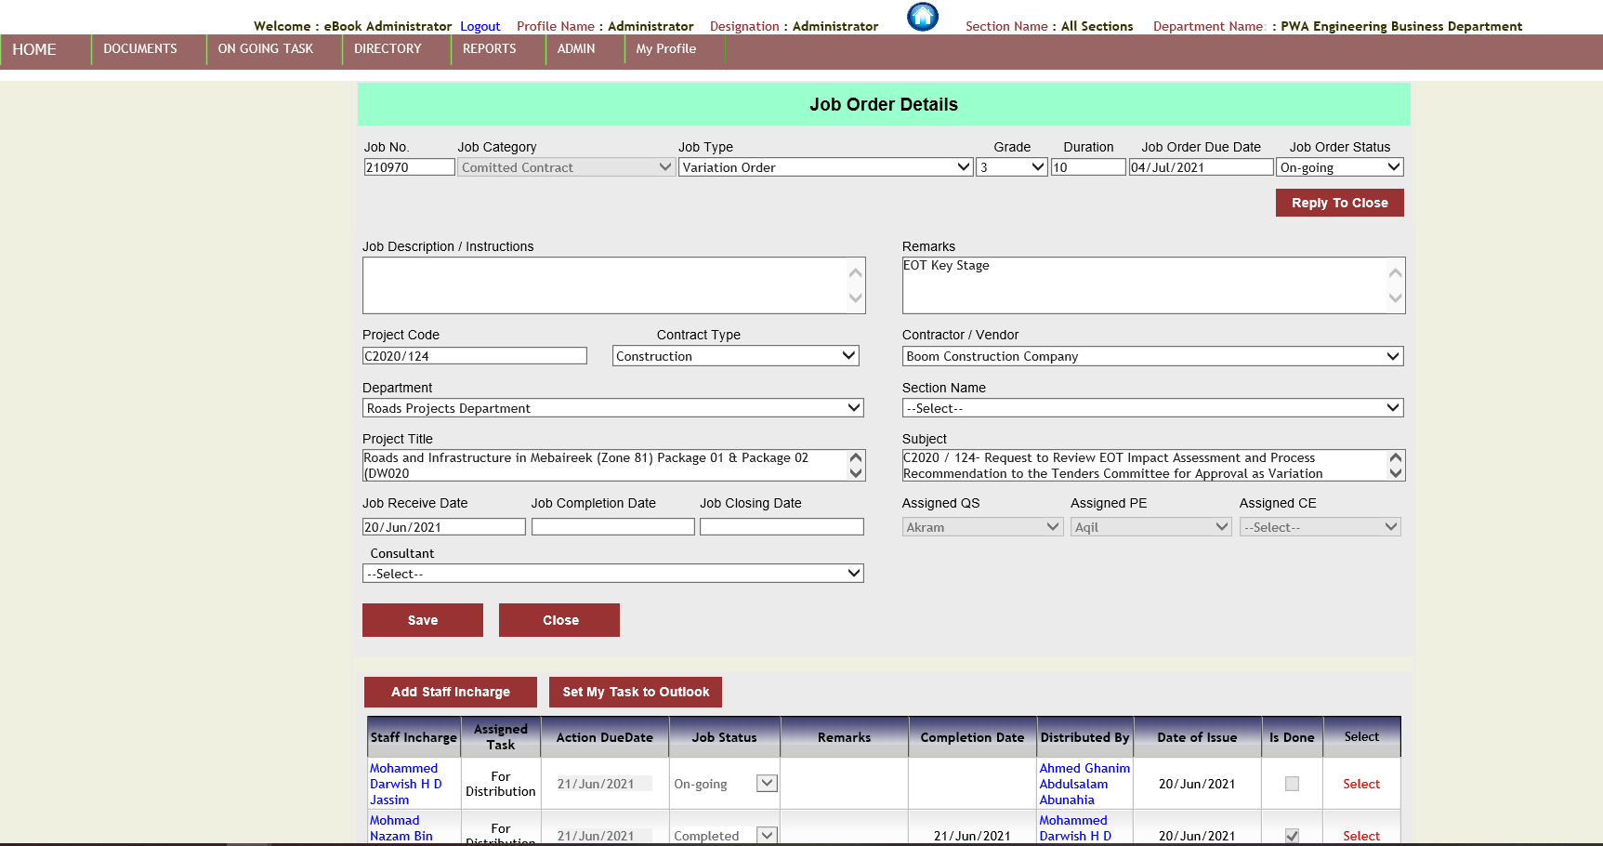

1. User can add received or send documents to the job. User clicks on document reference number from the below screenshot :-



1. The following web page opens :-

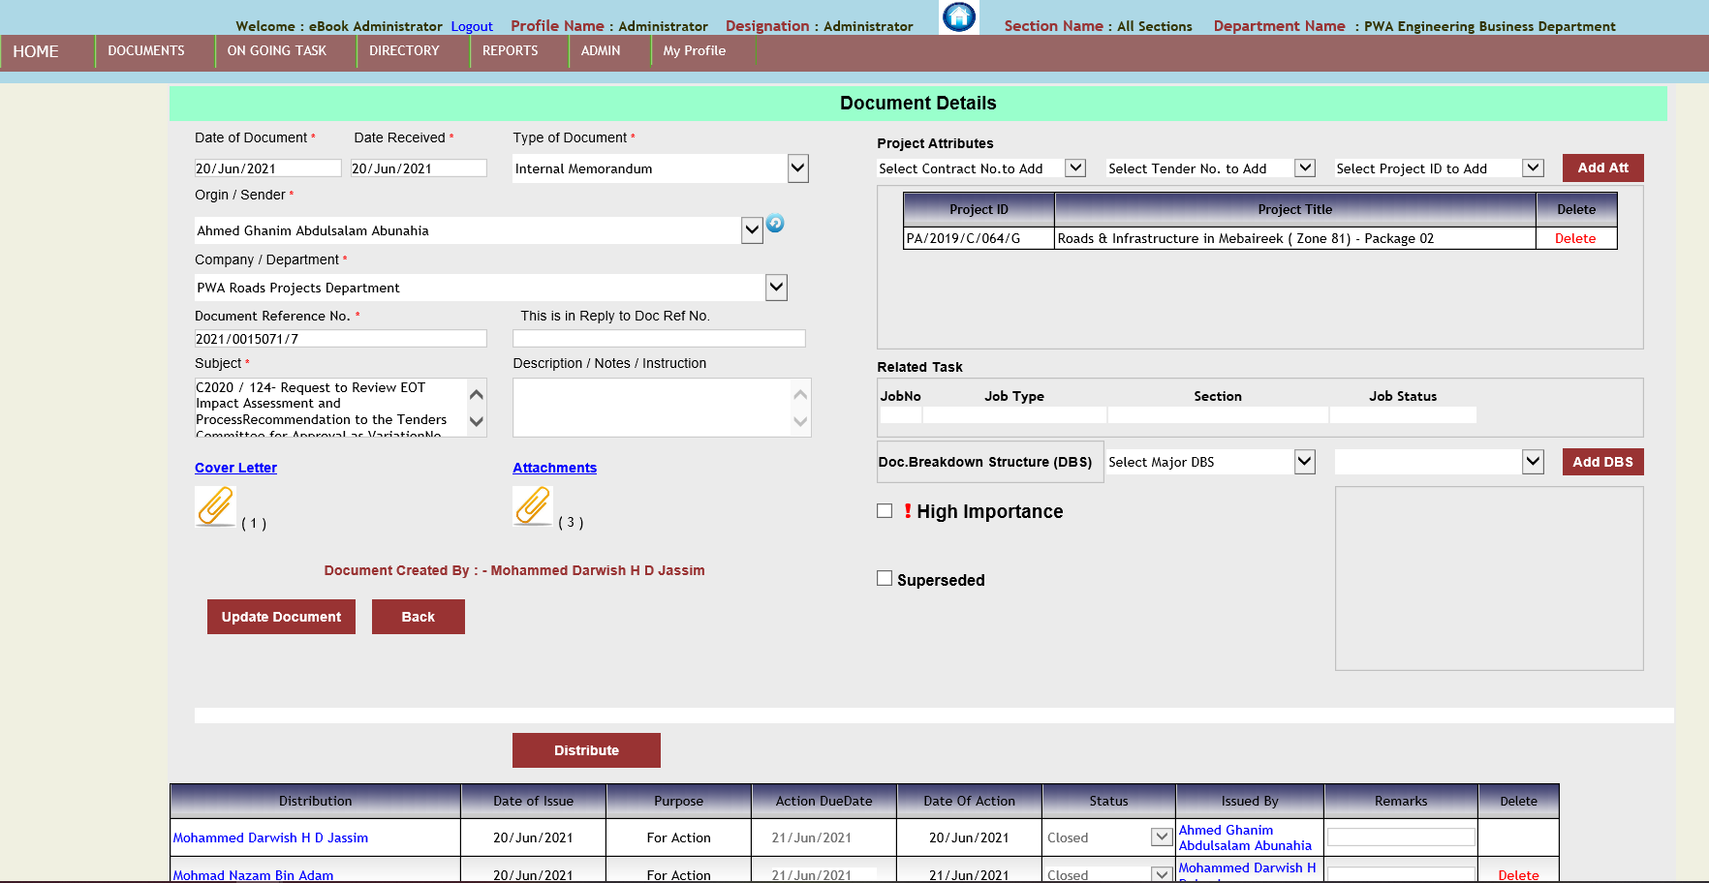

1. Based on access rights User can “Update the Document” data, attach the cover letter and attachments and add project attributes.

# How to access Payment Section task?

1. Hover the mouse cursor on “On Going Task” main menu on the menu bar. Click on “Payment Section” submenu.

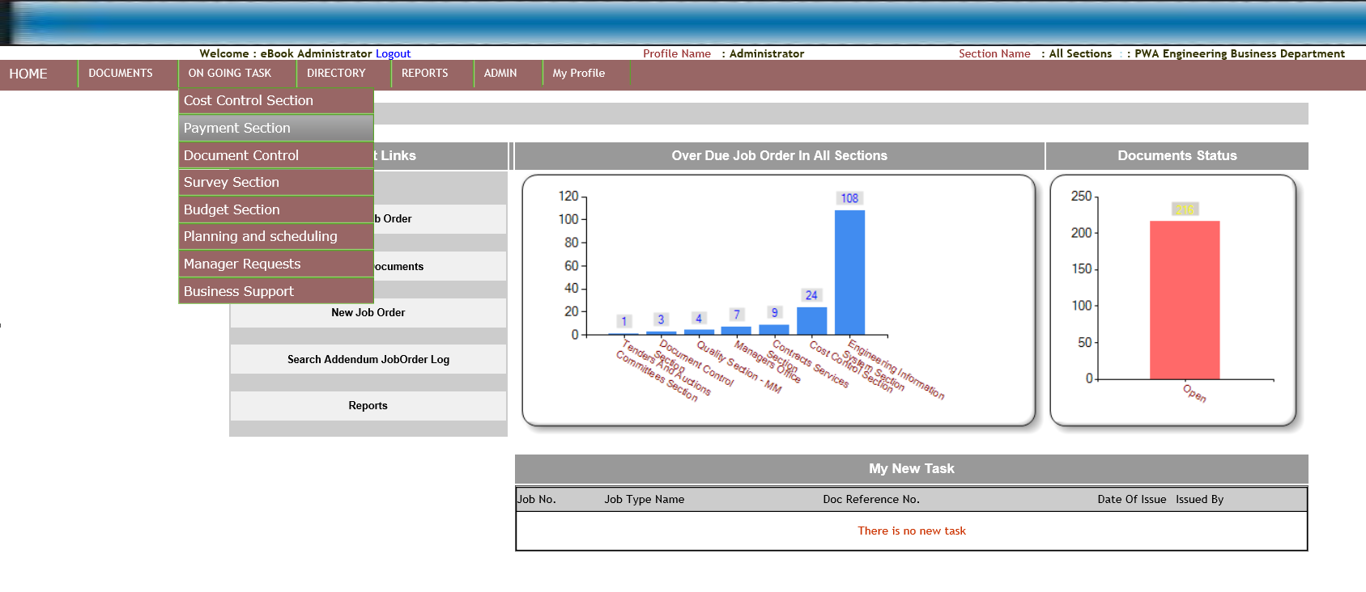

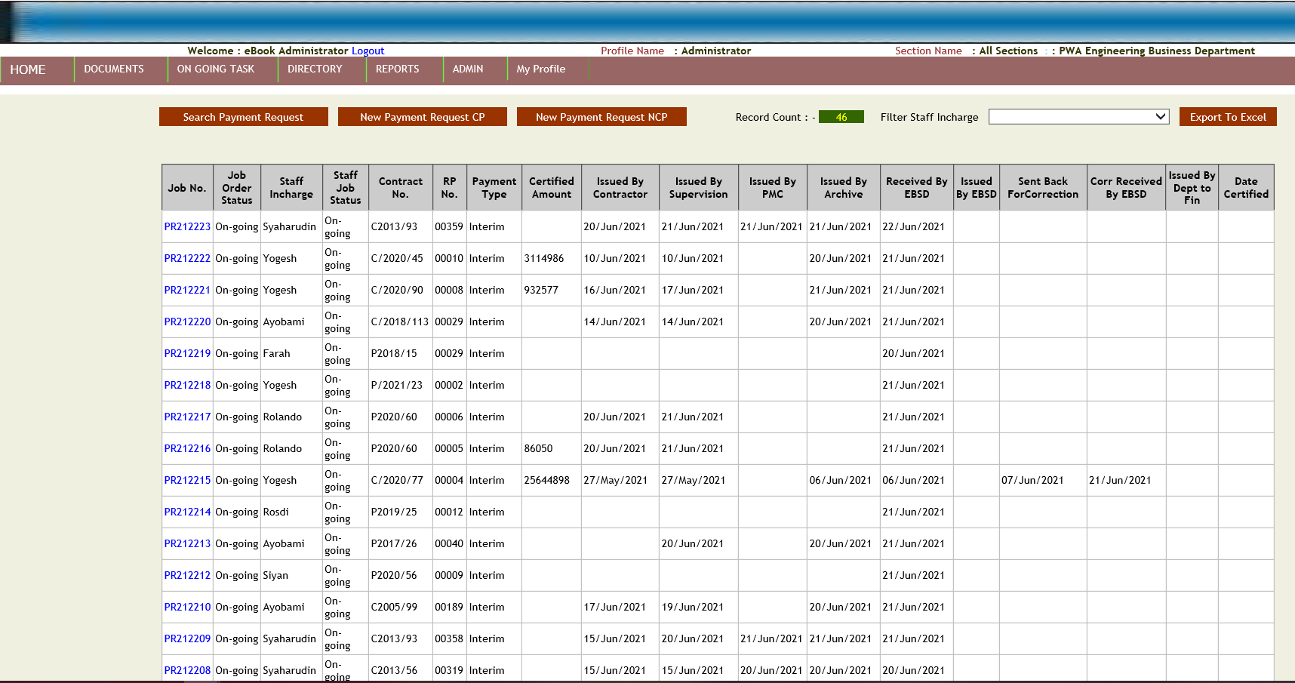

1. Click on the Job No. to view the details of the Payment job.

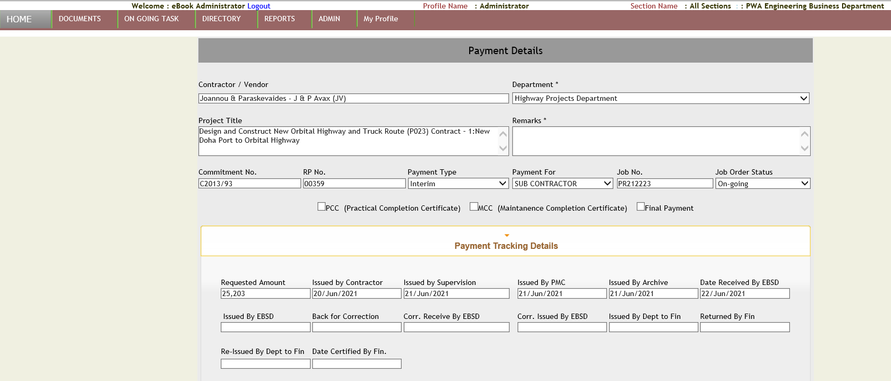

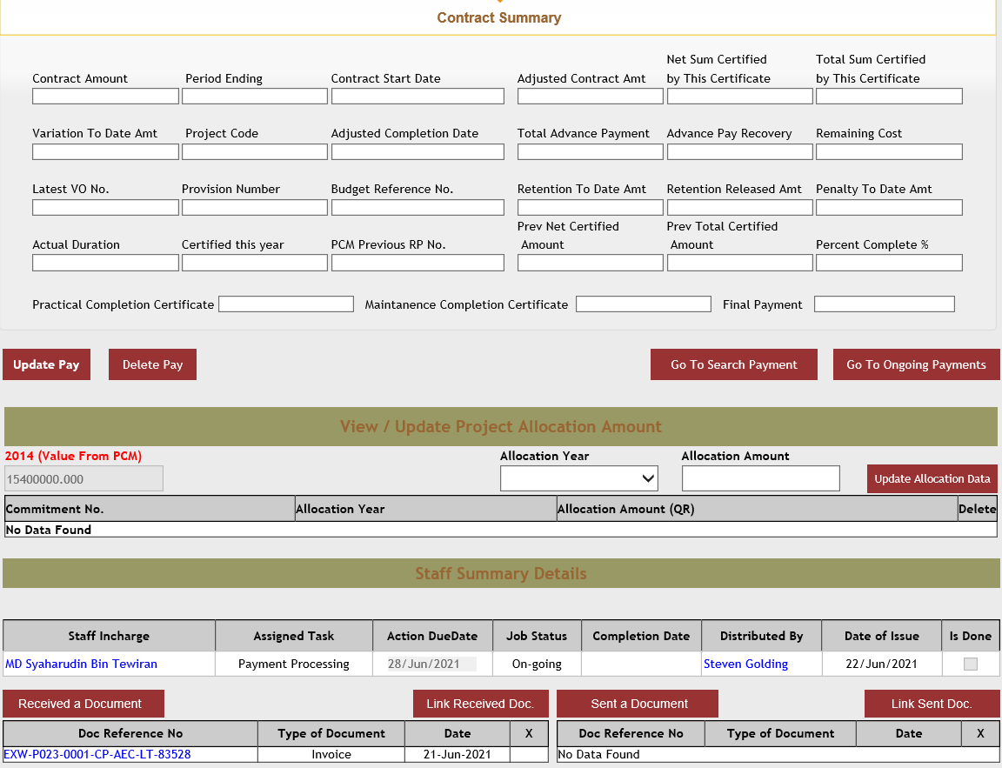

1. User can add received or send documents to the job. User clicks on document reference number from the below screenshot :-

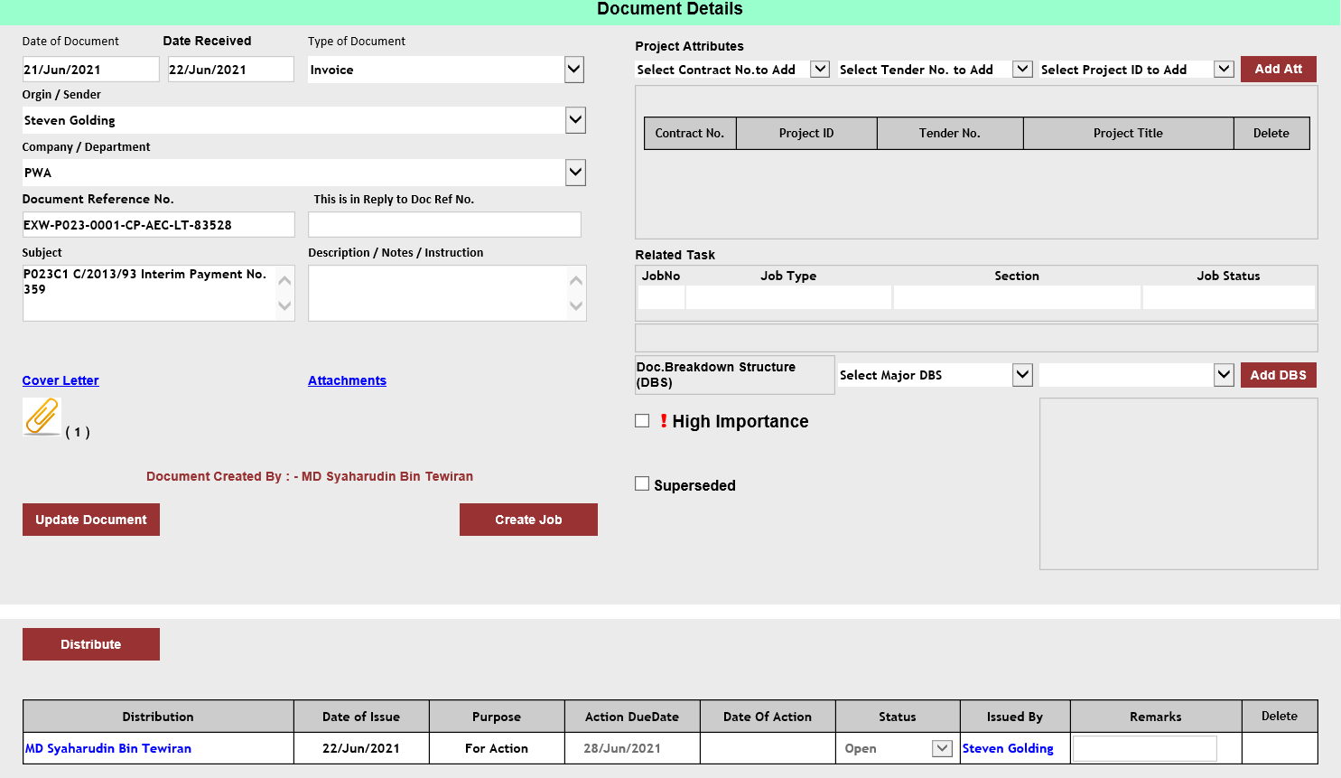

# How to access Document Control Section task?

1. Hover the mouse cursor on “On Going Task” main menu on the menu bar. Click on “Document Control Section” submenu.

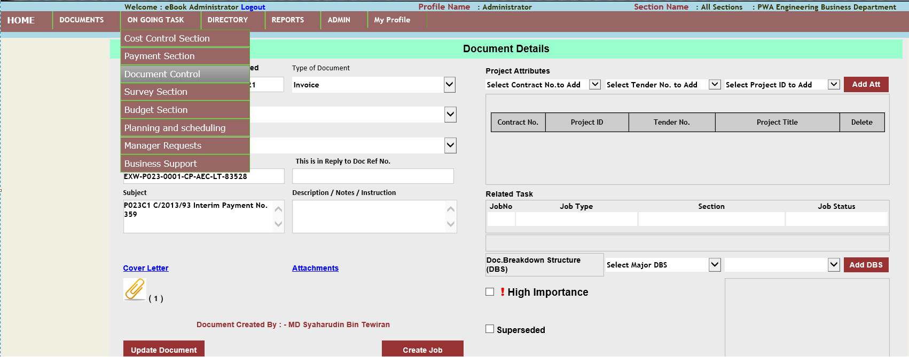

1. The following web page opens :-

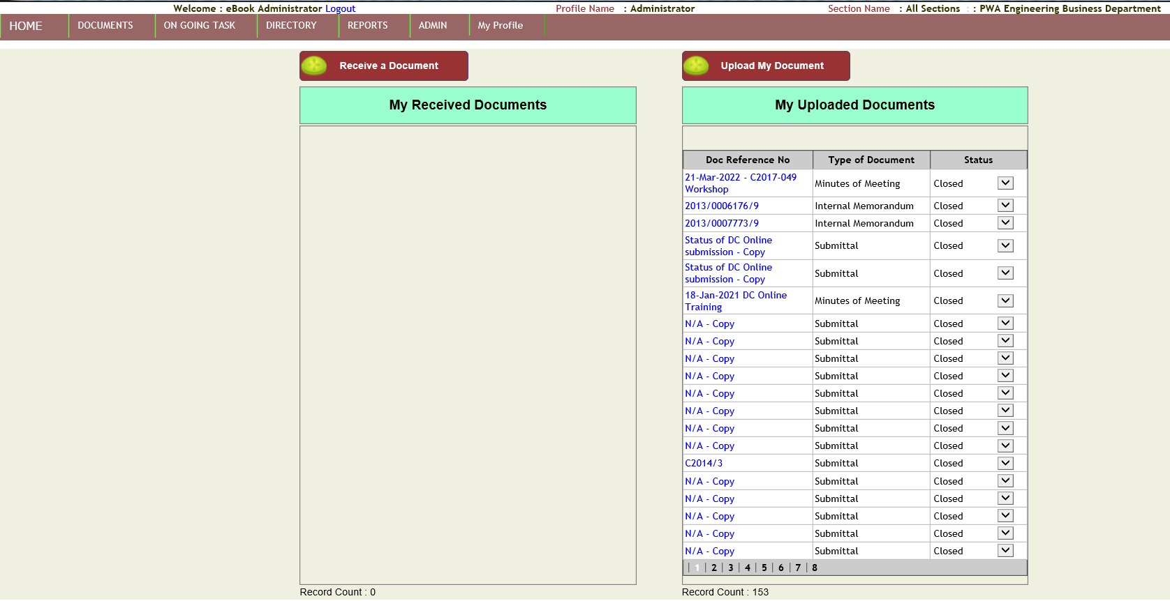

# How to access Budget Section task?

1. Hover the mouse cursor on “On Going Task” main menu on the menu bar. Click on “Budget Section” submenu.

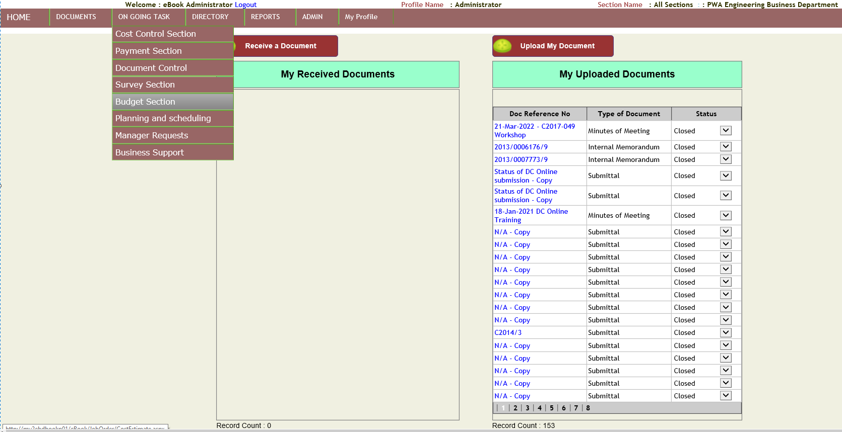

1. The following web page opens :-

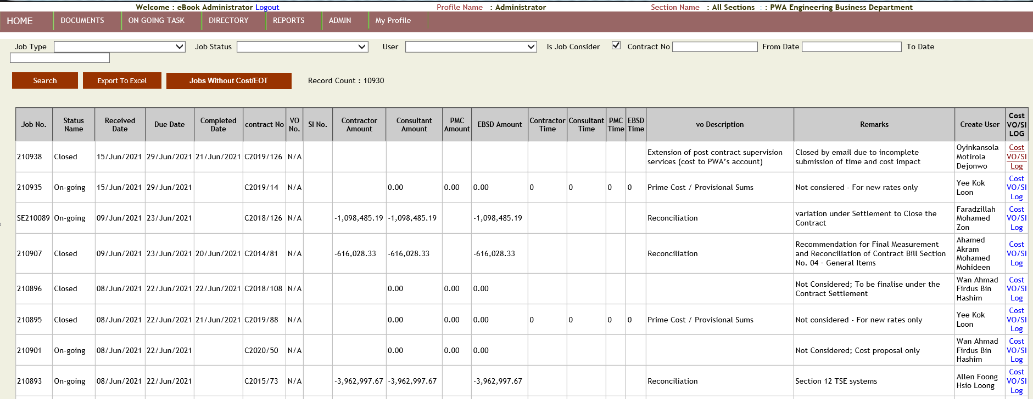

1. Click on “Cost VO/SI Log”. The following web page opens :-

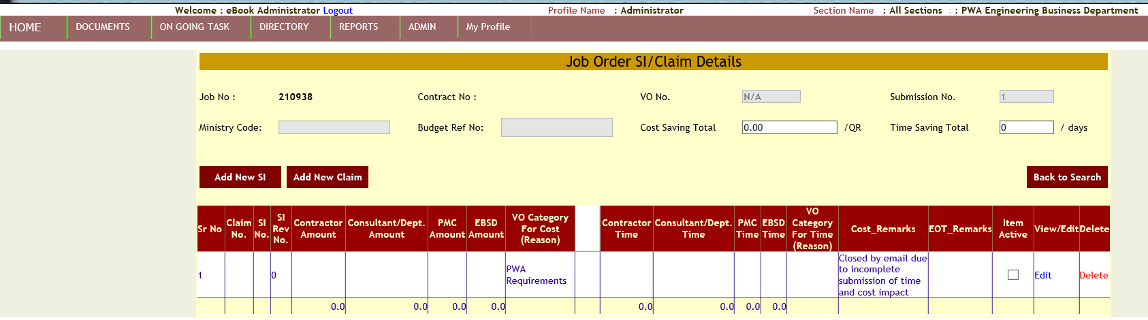

1. Click on “Add new SI” button. The following web page opens :-

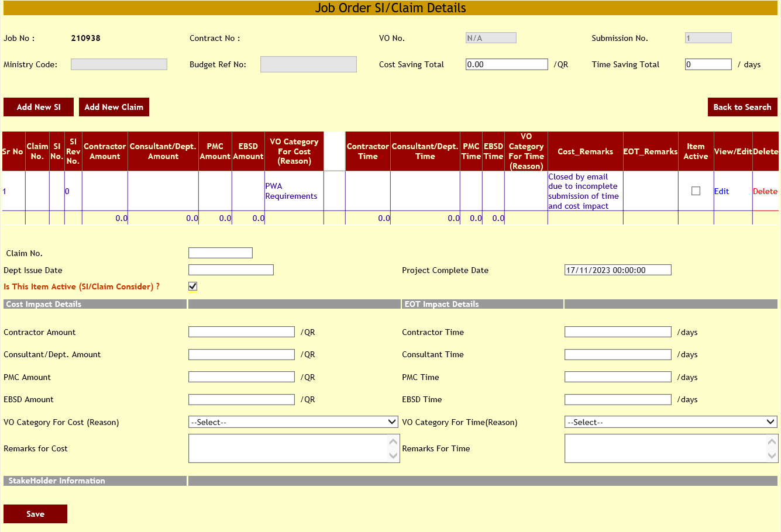

1. After clicking on “Add New SI” button, the application will display the text fields for taking the inputs to add new site instruction. Click on “Save” button to add new site instruction or new claim.

# How to access Planning and Scheduling task?

1. Hover the mouse cursor on “On Going Task” main menu on the menu bar. Click on “Planning and Scheduling” submenu.

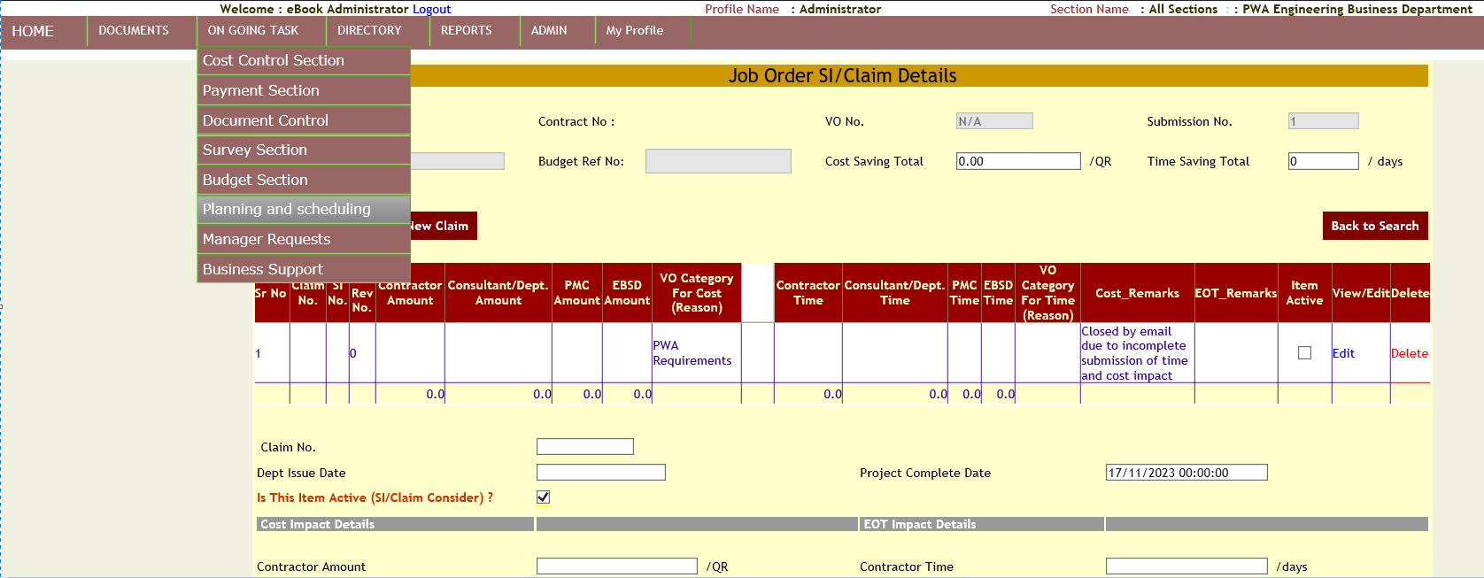

1. After clicking on “Search PS”. The following web page opens :-

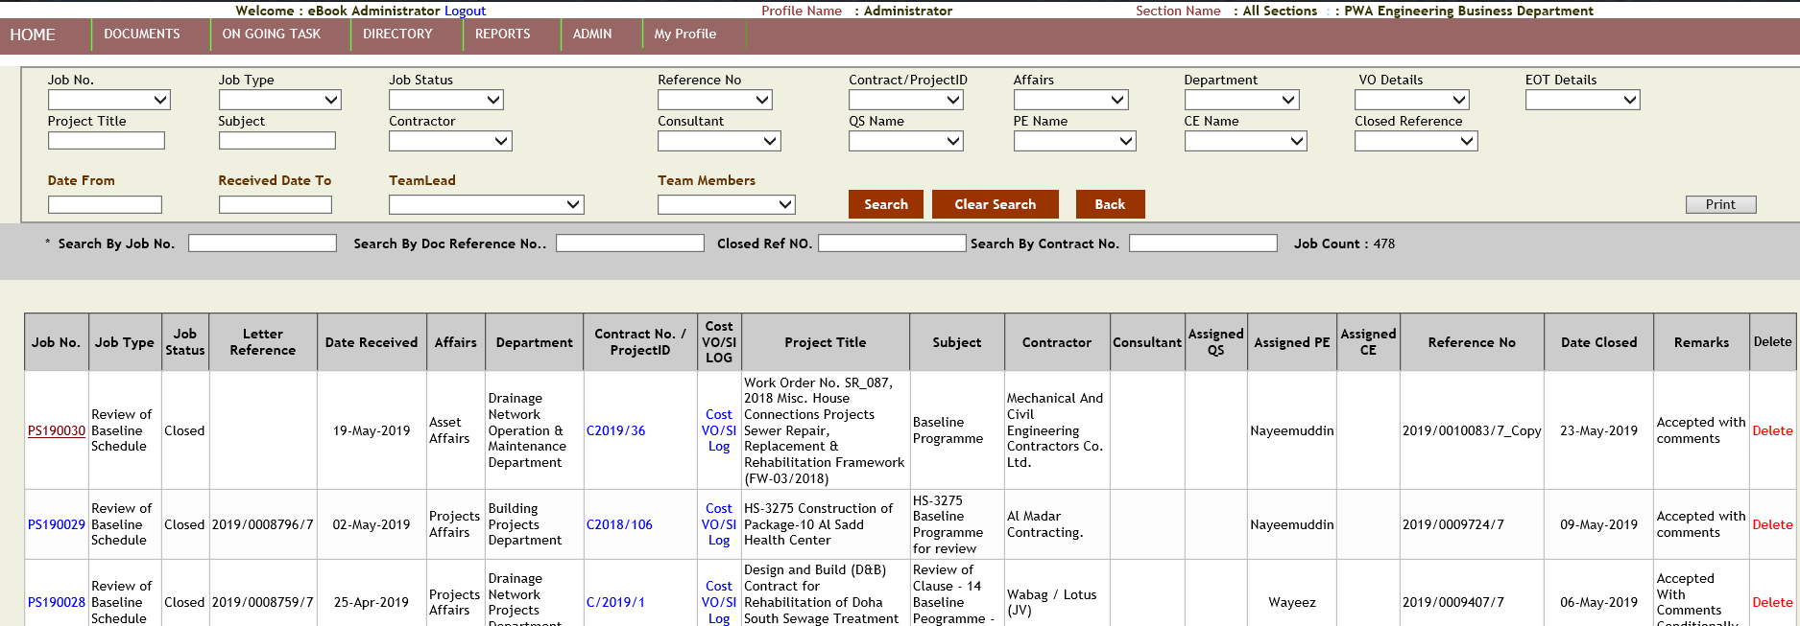

1. Click on the Job Number. The following web page opens :-

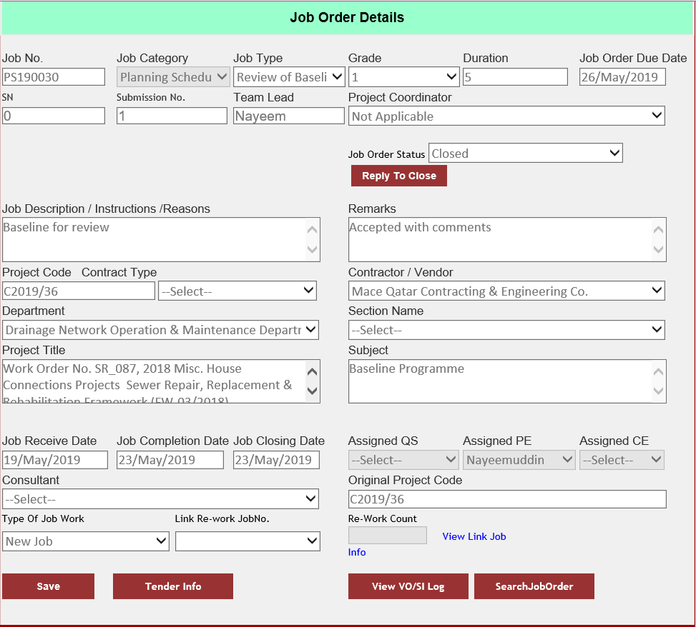

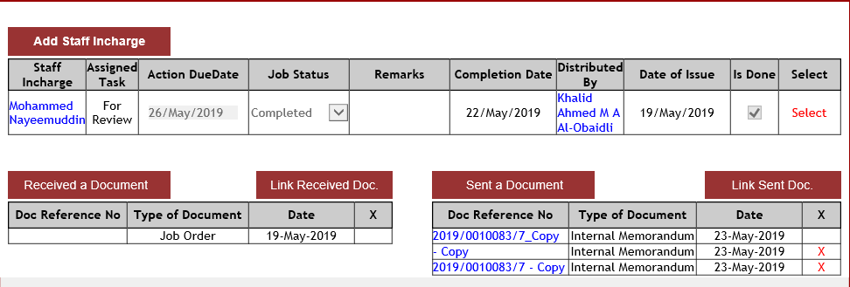

1. User clicks on “View VO/SI Log” button. The following web page opens :-

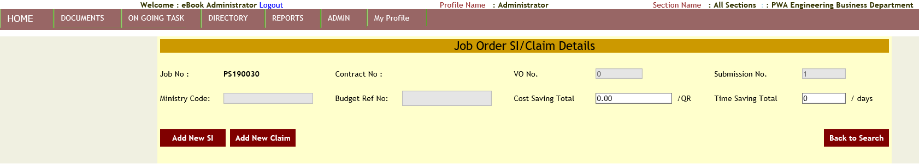

1. Click on “Add New SI” button. The following web page opens :-

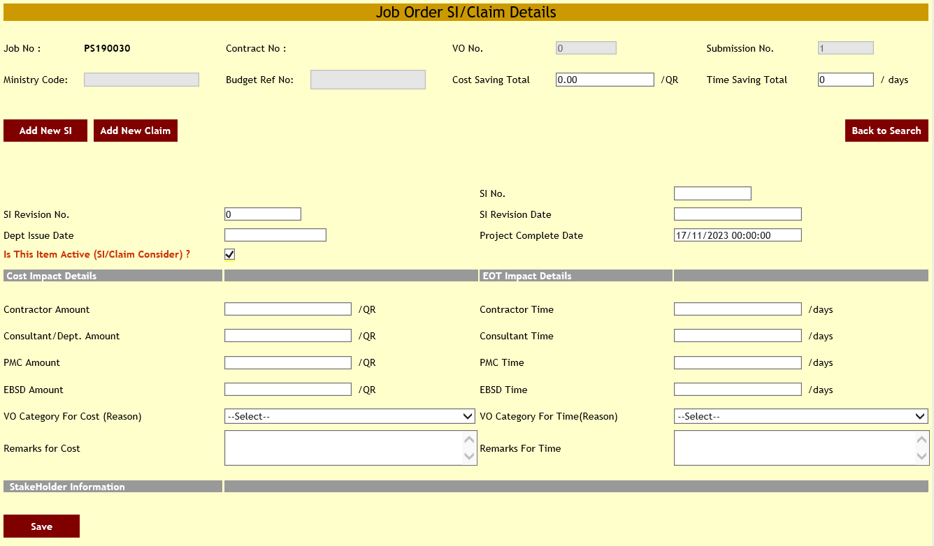

1. After clicking on “Add New SI” button, the application will display the text fields for taking the inputs to add new site instruction. Click on “Save” button to add new site instruction or new claim.

# How to access Manager Request’s task?

1. Hover the mouse cursor on “On Going Task” main menu on the menu bar. Click on “Manager Requests” submenu.

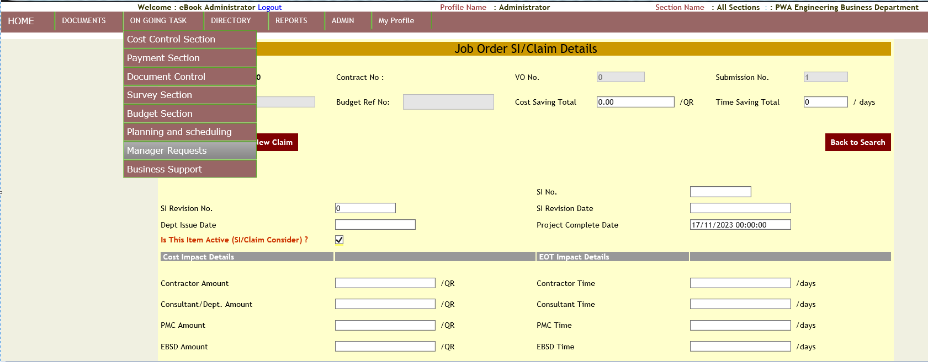

1. After clicking on “Manager Requests” menu item. The following web page opens :-

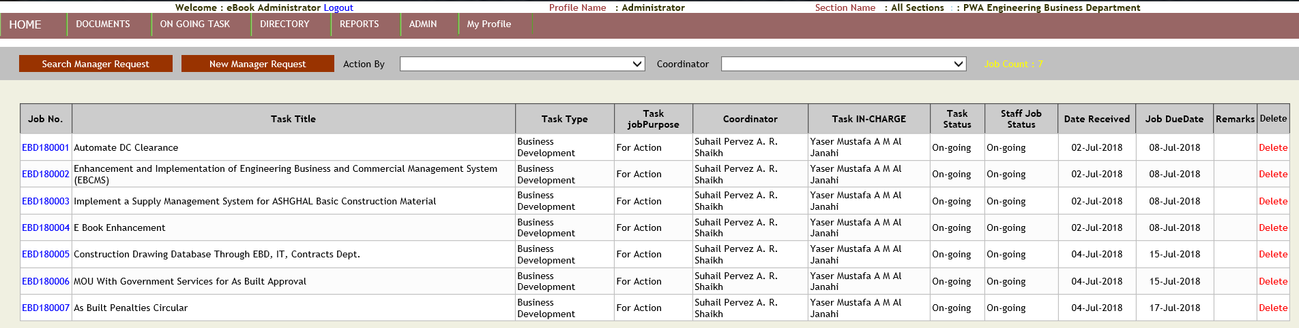

1. Click on “Search Manager Request” button the following web page opens :-

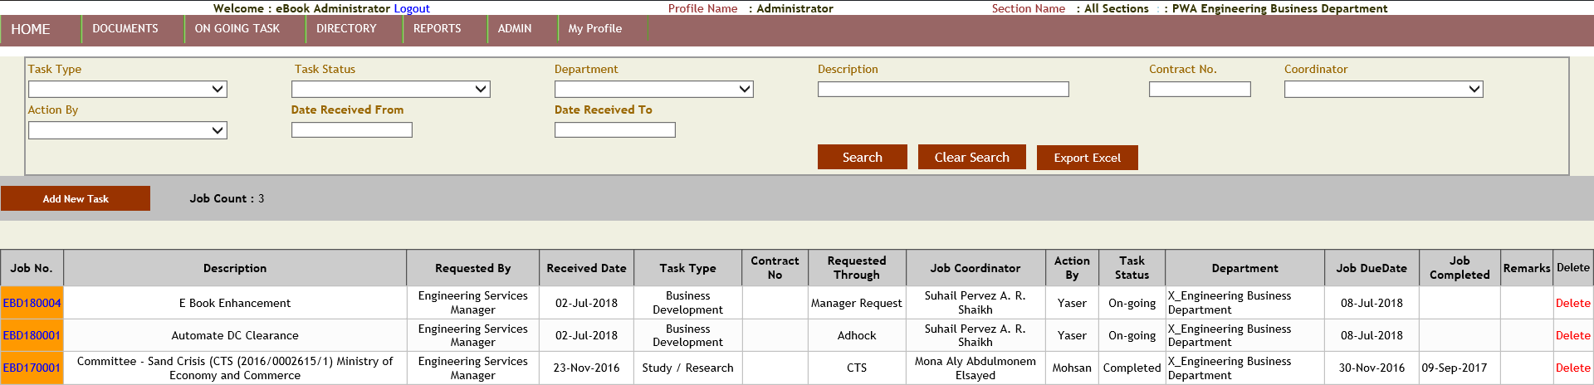

1. Click on the Job number. The following web page opens :-

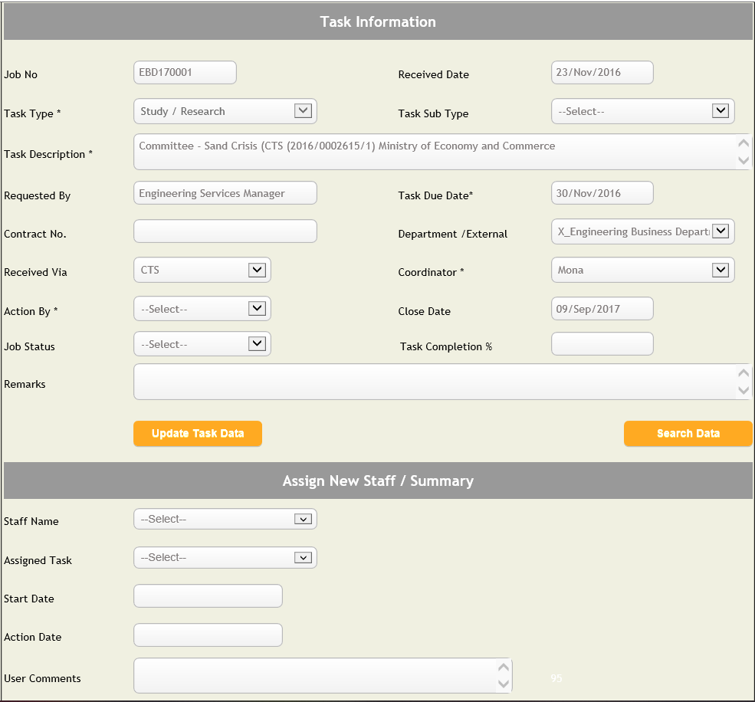

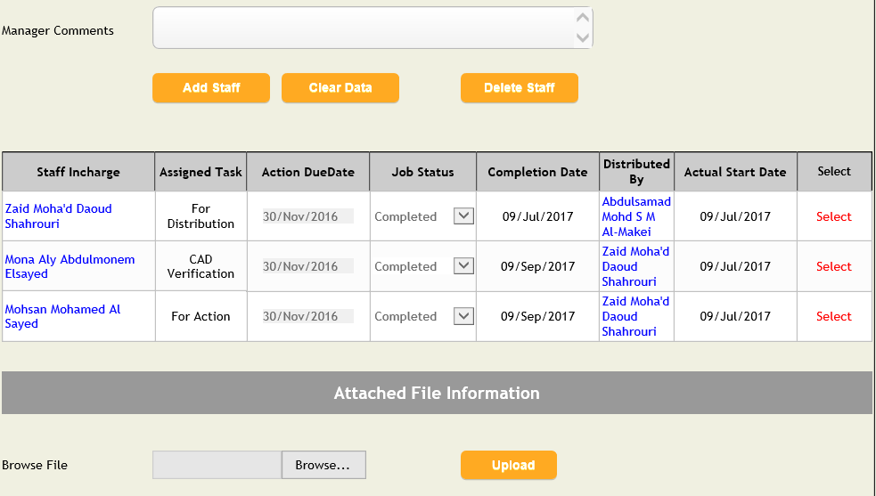

1. Click on “Update Task Data” for updating the Job information.
2. After selecting the staff name click on “Add Staff” button to add task to the staff.
3. Click on “Add New Task” for adding new task.



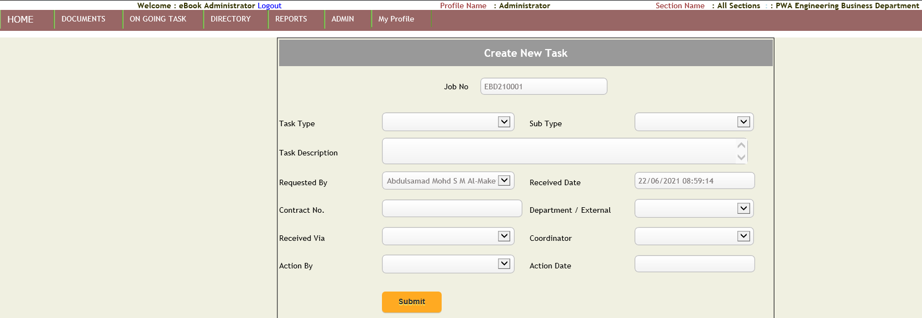

1. Click on “Search” button to search for Job number. Click on “Clear Search” for clearing the texts in the text fields for searching. Click on “Export Excel” button for exporting the searched Job numbers into an excel sheet.

# How to access Business Support task?

1. Hover the mouse cursor on “On Going Task” main menu on the menu bar. Click on “Business Support” submenu.

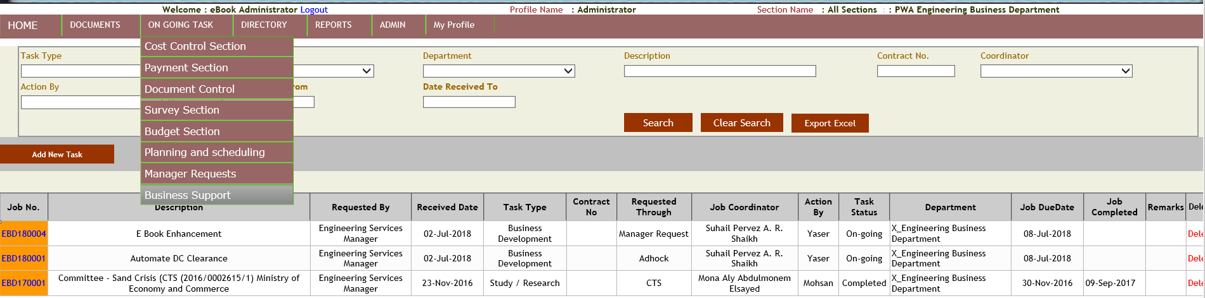

1. The following web page opens :-

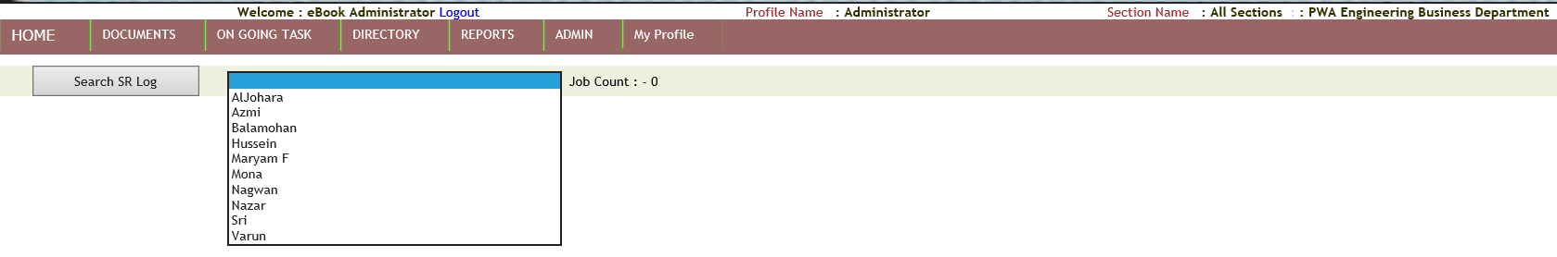

1. On the selection of staff from the dropdown list. The following records will be displayed :-

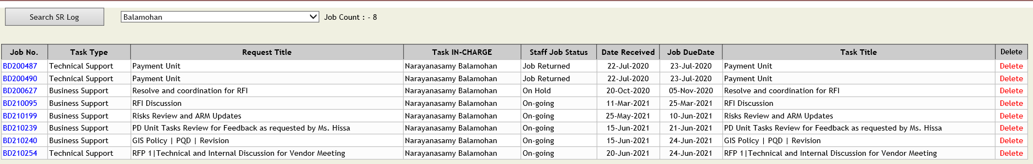

1. Click on the Job number to view the details of the Job.

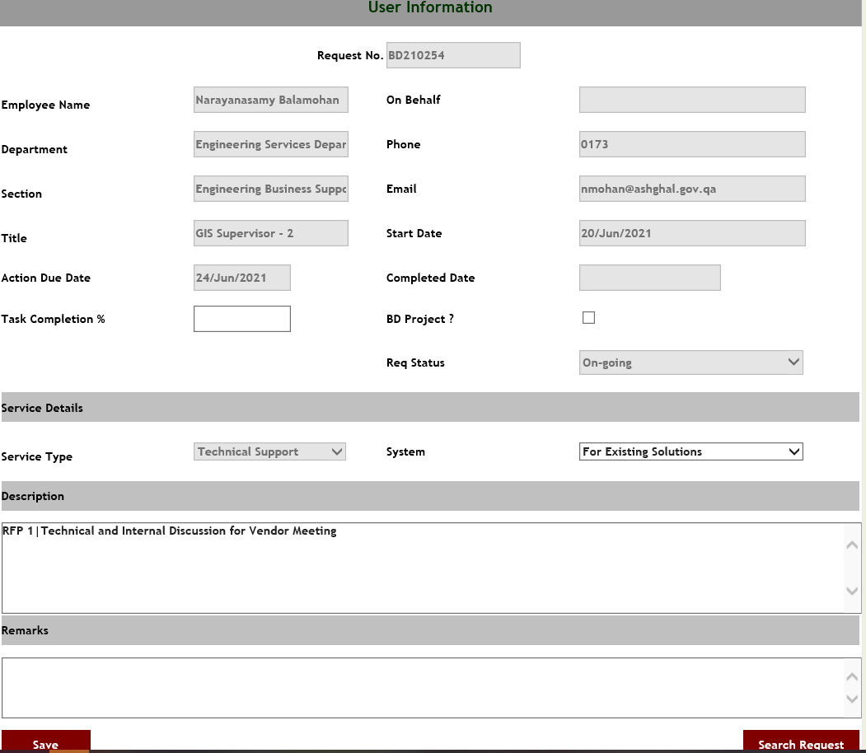

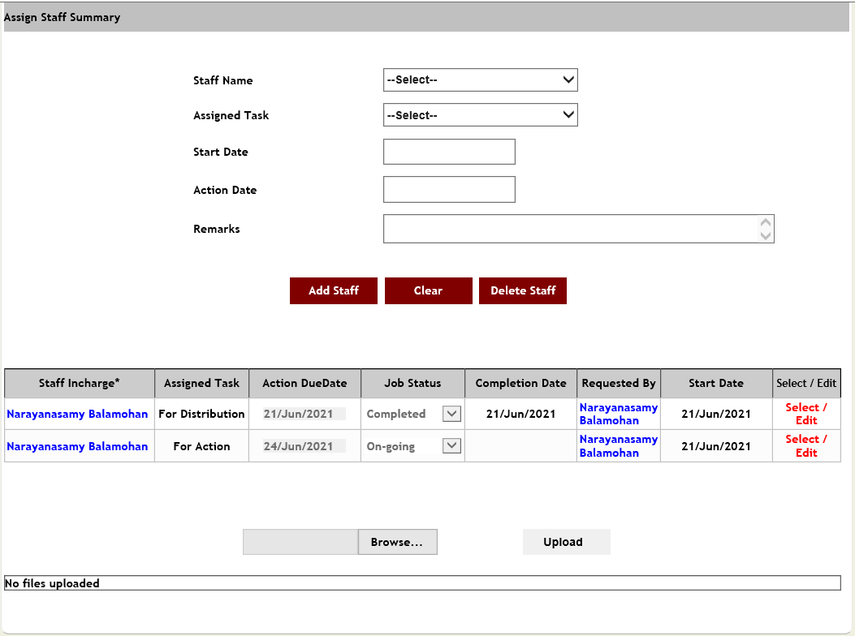

# How to access Documents?

1. Hover the mouse cursor on “Documents” main menu on the menu bar. Click on “Documents” link.

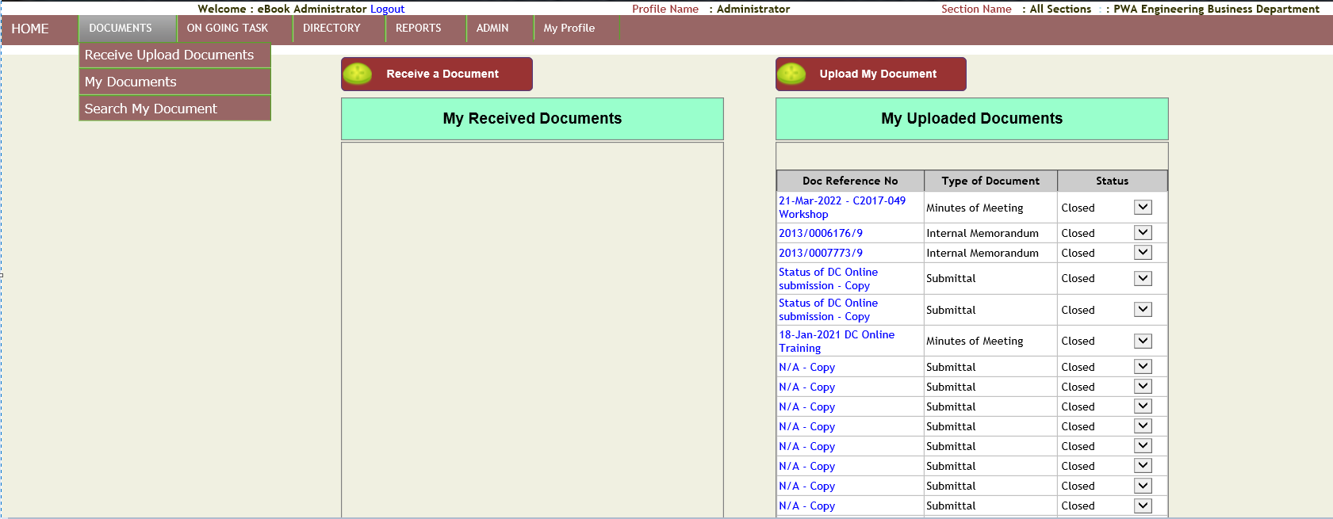

# How to access Search My Document?

1. Hover the mouse cursor on “Documents” main menu on the menu bar. Click on “Search My Document” submenu.

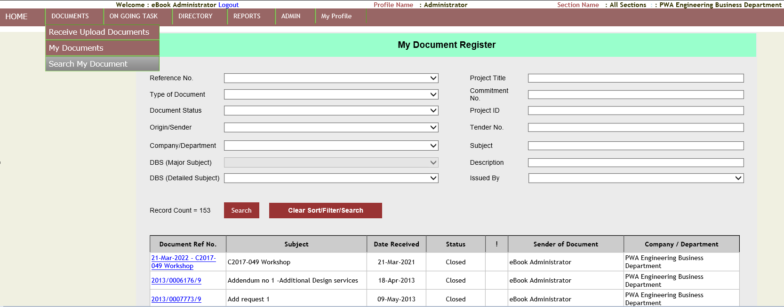

# How to access Receive Upload Documents?

1. Hover the mouse cursor on “Documents” main menu on the menu bar. Click on “Receive Upload Documents” submenu.

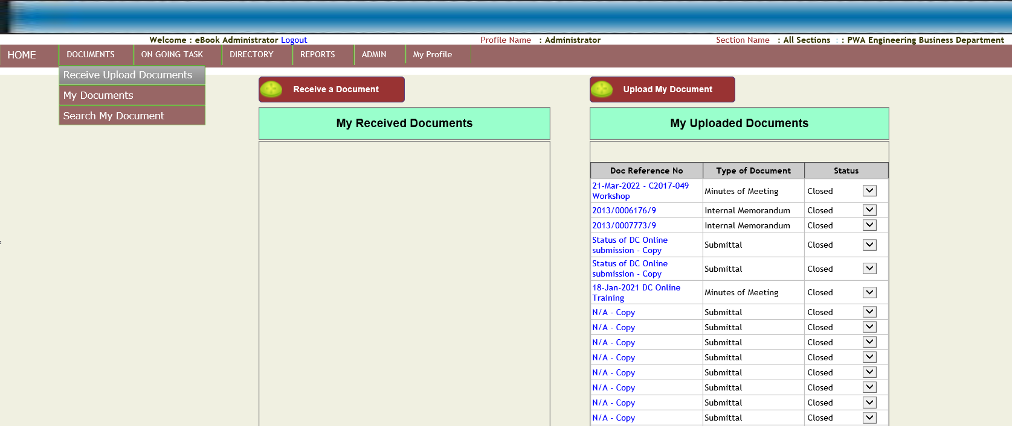

1. User clicks on Document Reference Number. The following web page opens :-

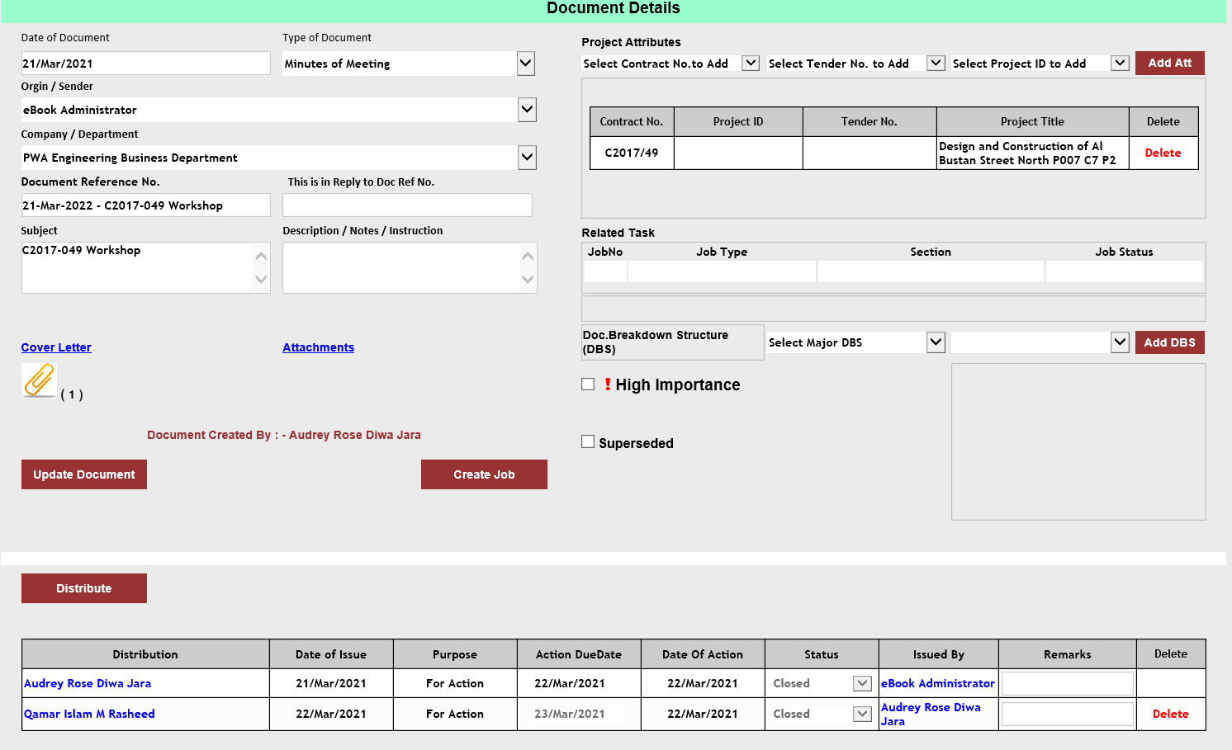

1. Based on access rights User can “Update the Document” data, attach the cover letter, attachments, add project attributes and Create Job.

# How to access My Documents?

1. Hover the mouse cursor on “Documents” main menu on the menu bar. Click on “My Documents” submenu.

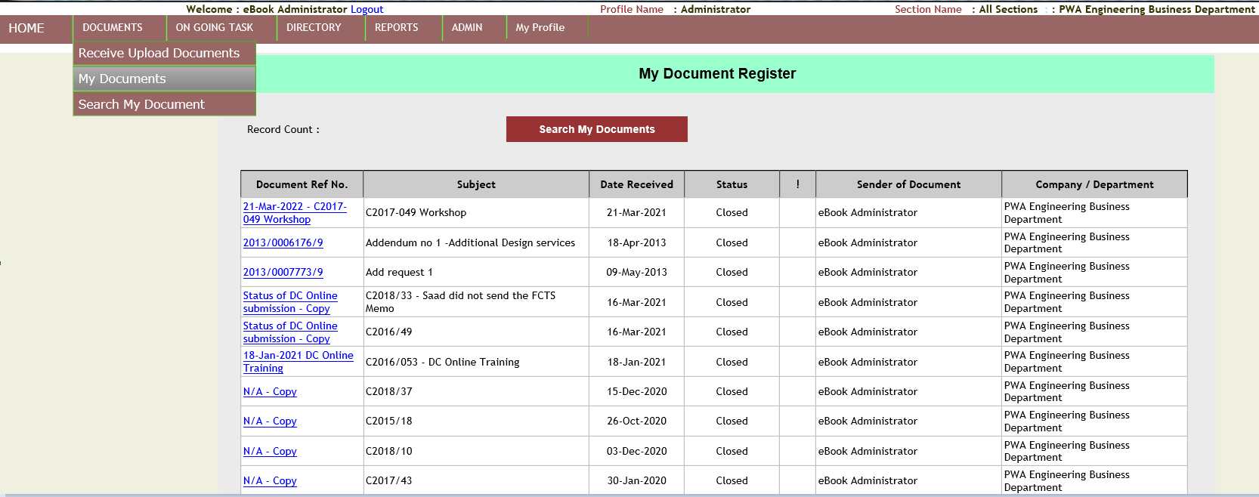

1. User clicks on “Search My Documents” button, the following web page opens :-

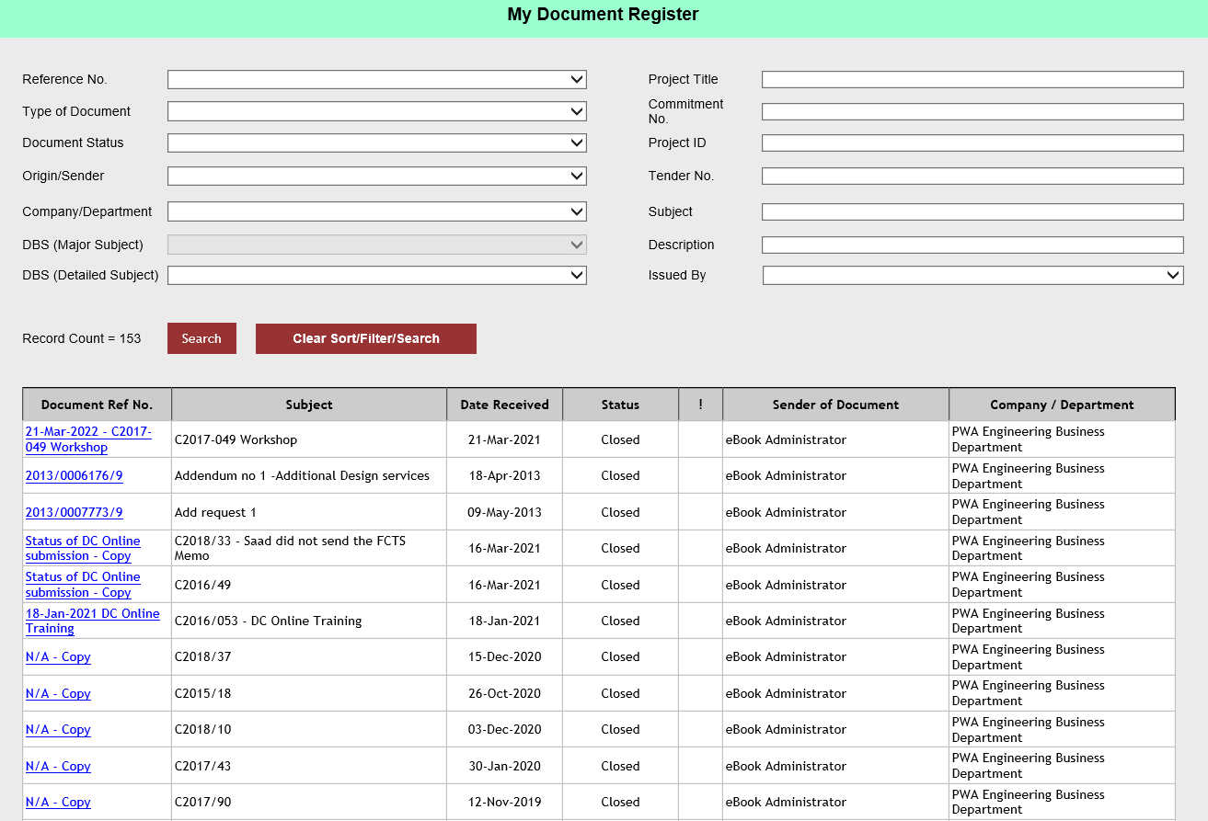

1. User selects the inputs from the dropdown list and textboxes above the Search button. After selecting an item from the dropdown list and entering the text inside the textboxes. User clicks on “Submit” button. The application will display the record below the Search button if there is any.

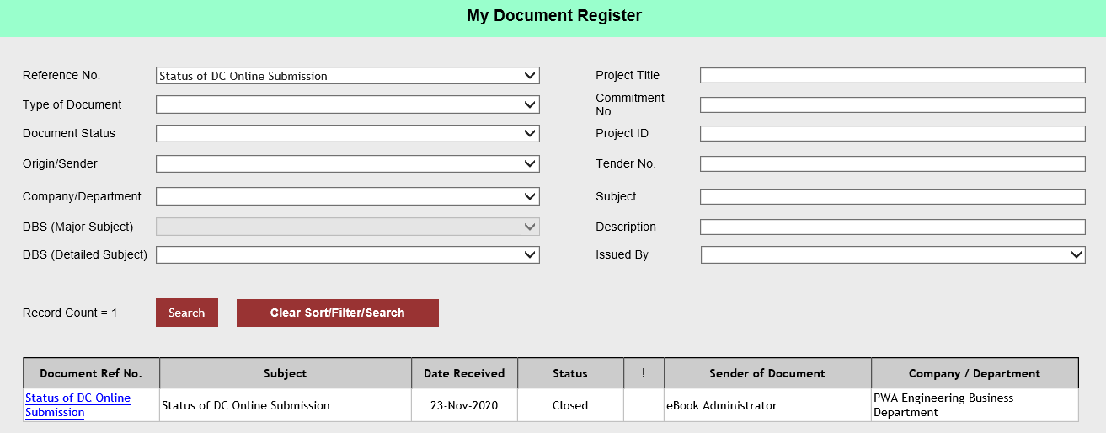

# How to access Reports?

1. Hover the mouse cursor on “Reports” main menu on the menu bar. Click on “Reports” main menu.

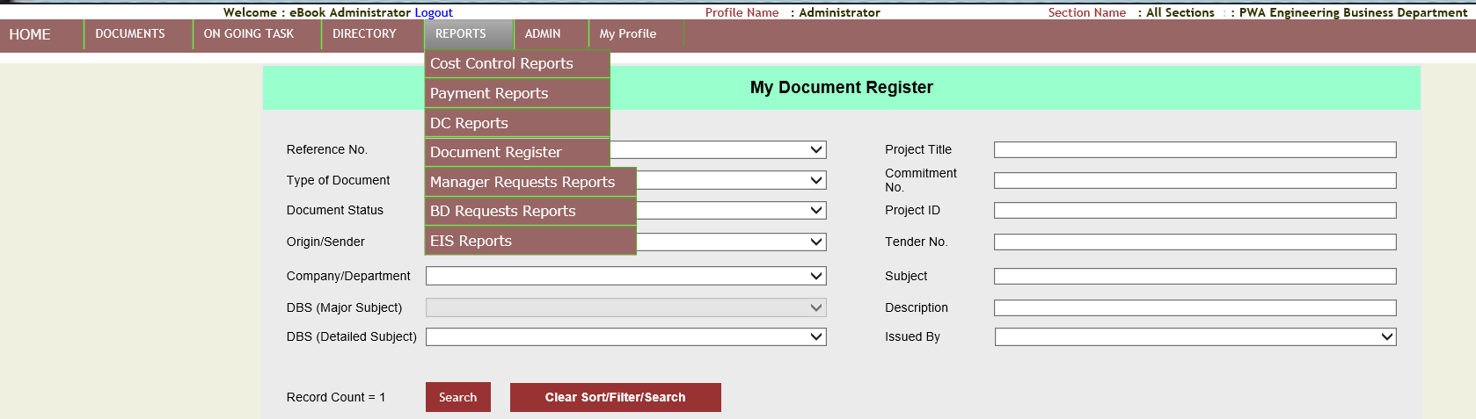

1. The following web page opens :-

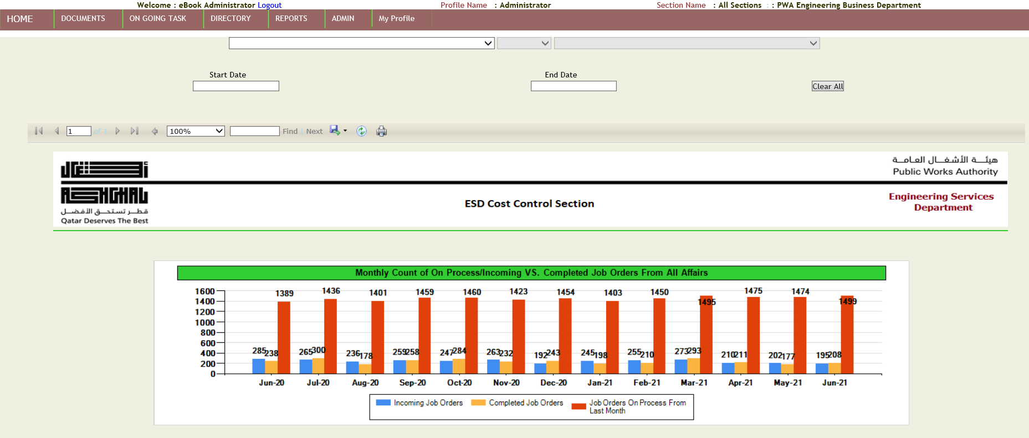

1. User selects “Reports By Average Work days”

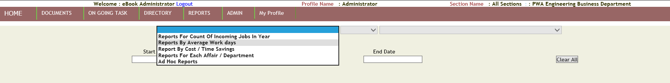

1. User selects “Reports for PSA Contracts” from the second dropdown list. The following report will display:-

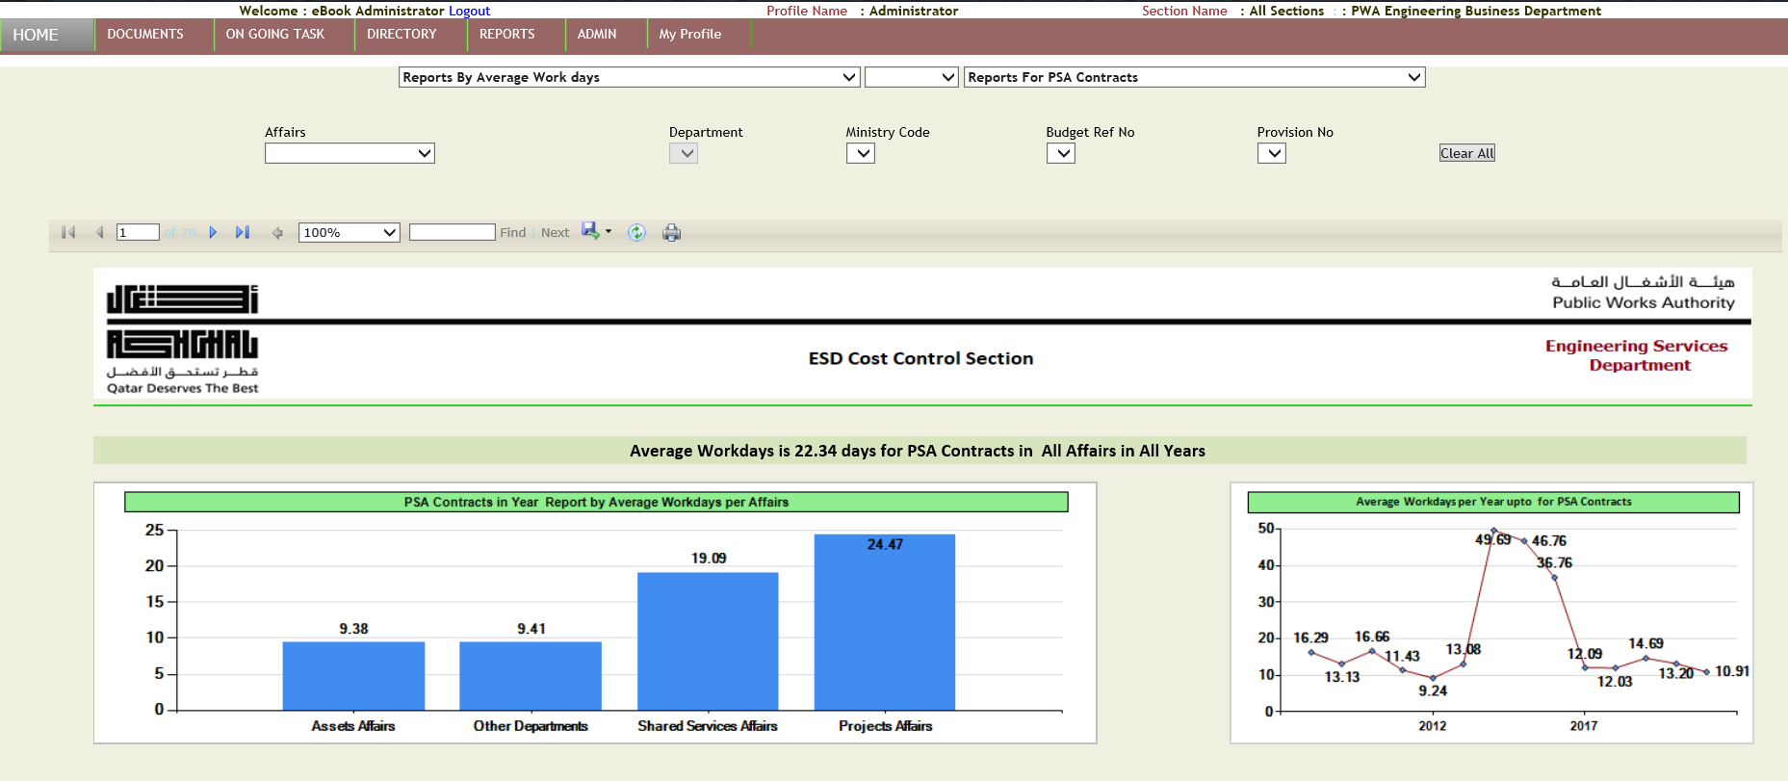

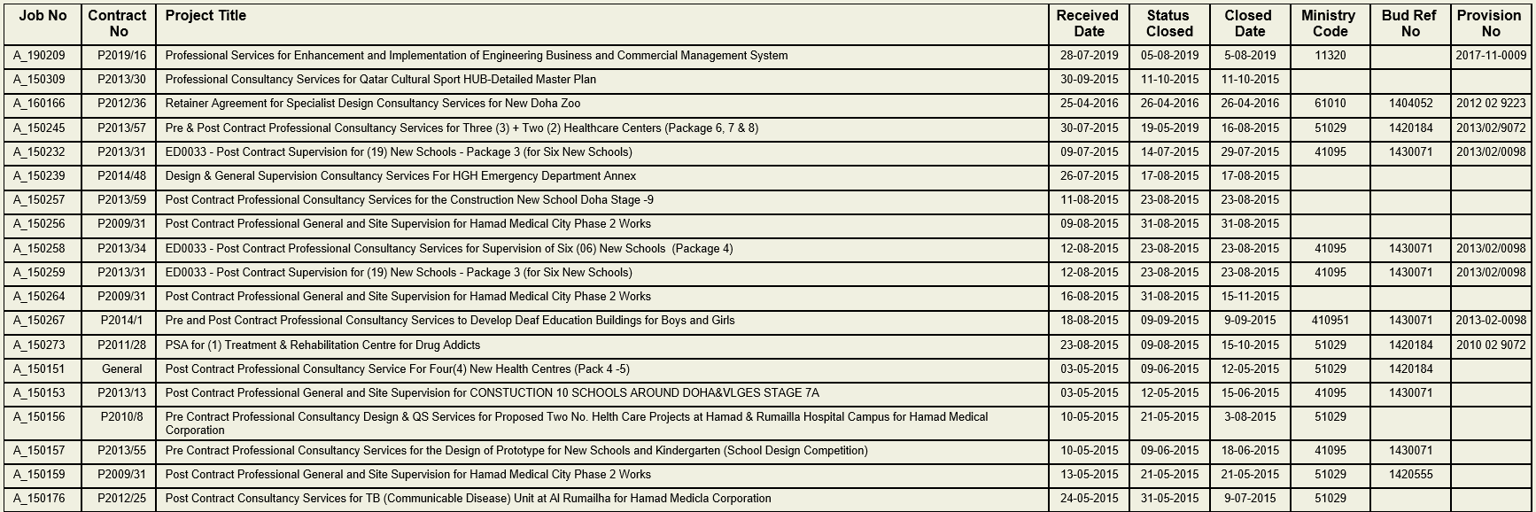

# How to access Project Coordinators in EBook application?

1. Hover the mouse cursor on “Directory” main menu on the menu bar. Click on “Project Coordinators” sub menu.

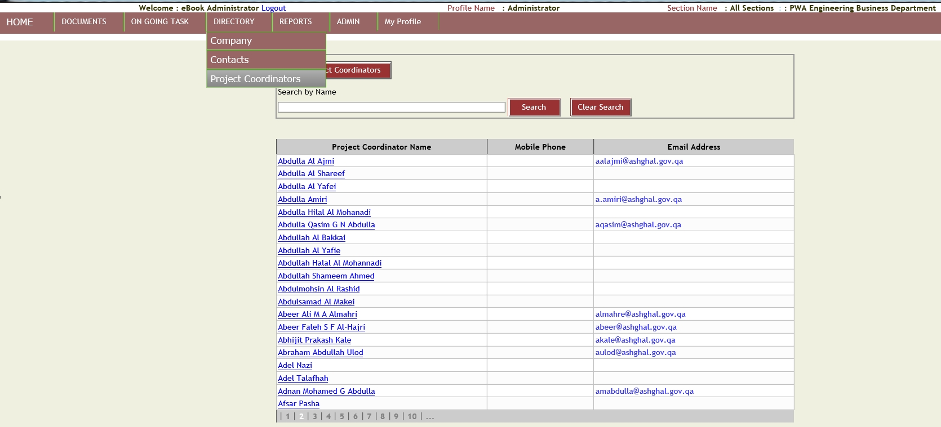

1. Enter the text inside the search by name textbox to search for the project coordinator. Either click outside the textbox or click on “Search” button.

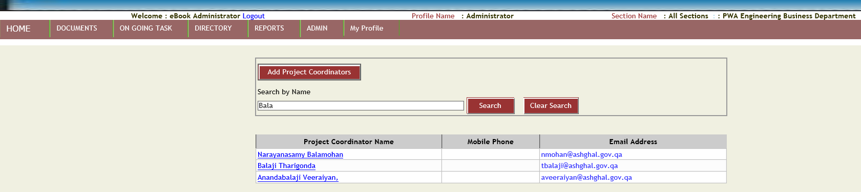

1. To edit the project coordinator details click on the “Project Coordinator” link. The application will open a new web page :-

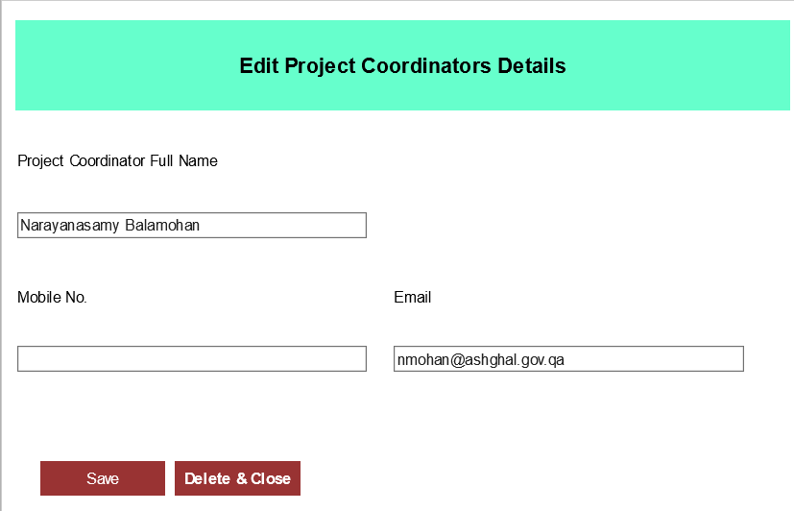

1. User can edit the project coordinator full name, mobile number and email address. Click on “Save” button to save the changes.
2. User clicks on “Delete and Close” button for deleting the project coordinator name.

# How to navigate to the dashboard of EBook application?

1. Hover the mouse cursor on “Home” main menu on the menu bar. Click on “Home” main menu.

